Fire Safety training and Fire Extinguishers
The Fire Triangle:
In order to understand how fire extinguishers work, you first need to know a little bit about fire.
Four things must be present at the same time in order to produce fire:
- Enough oxygen to sustain combustion,
- Enough heat to raise the material to its ignition temperature,
- Some sort of fuel or combustible material, and
- The chemical, exothermic reaction that is fire.
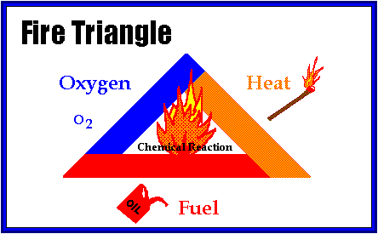
Oxygen, heat (source of ignition), and fuel are frequently referred to as the "fire triangle." Add in the fourth element, the chemical reaction, and you actually have a fire "tetrahedron." The important thing to remember is: take any of these theee things away, and you will not have a fire or the fire will be extinguished.
Essentially, fire extinguishers put out fire by taking away one or more elements of the fire triangle/tetrahedron.
Fire safety, at its most basic, is based upon the principle of keeping fuel sources and ignition sources separate.
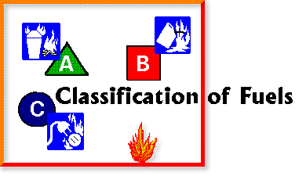
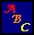
Not all fires are the same, and they are classified according to the type of fuel that is burning. If you use the wrong type of fire extinguisher on the wrong class of fire, you can, in fact, make matters worse. It is therefore very important to understand the four different fire classifications.
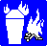 | Class A - Wood, paper, cloth, trash, plastics  Solid combustible materials that are not metals. (Class A fires generally leave an Ash.)
Class B - Flammable liquids: gasoline, oil, grease, acetone
Any non-metal in a liquid state, on fire. This classification also includes flammable gases. (Class B fires generally involve materials that Boil or Bubble.)
Class C - Electrical: energized electrical equipment
As long as it's "plugged in," it would be considered a class C fire. (Class C fires generally deal with electrical Current.)
Class D - Metals: potassium, sodium, aluminum, magnesium
Unless you work in a laboratory or in an industry that uses these materials, it is unlikely you'll have to deal with a Class D fire. It takes special extinguishing agents (Metal-X, foam) to fight such a fire.
Most fire extinguishers will have a pictograph label telling you which classifications of fire the extinguisher is designed to fight.

Types Of Fire Extinguishers:
Different types of fire extinguishers are designed to fight different classes of fire. The three most common types of fire extinguishers are:
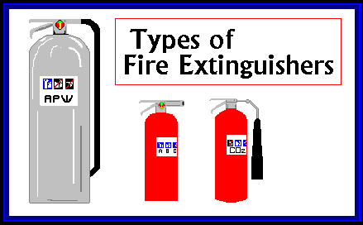
Water (APW)
Carbon Dioxide (CO2)
Dry Chemical (ABC,BC,DC)

Rules For Fighting Fires:
Fires can be very dangerous and you should always be certain that you will not endanger yourself or others when attempting to put out a fire. For this reason, when a fire is discovered:
- Assist any person in immediate danger to safety, if it can be accomplished without risk to yourself.
- Activate the building fire alarm system or notify the fire department by dialing 911 (or designating someone else to notify them for you). When you activate the building fire alarm system, it will automatically notify the fire department and get help on the way. It will also sound the building alarms to notify other occupants, and it will shut down the air handling units to prevent the spread of smoke throughout the building.
- Only after having done these two things, if the fire is small, you may attempt to use an extinguisher to put it out.
However, before deciding to fight the fire, keep these rules in mind:
Know what is burning. If you don't know what is burning, you don't know what type of extinguisher to use. Even if you have an ABC extinguisher, there may be something in the fire that is going to explode or produce highly toxic smoke. Chances are, you will know what's burning, or at least have a pretty good idea, but if you don't, let the fire department handle it.
The fire is spreading rapidly beyond the spot where it started. The time to use an extinguisher is in the incipient, or beginning, stages of a fire. If the fire is already spreading quickly, it is best to simply evacuate the building, closing doors and windows behind you as you leave.
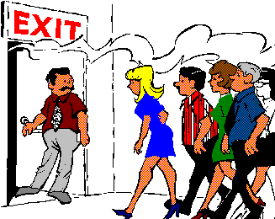

Do Not Fight the Fire If:
You don't have adequate or appropriate equipment. If you don't have the correct type or large enough extinguisher, it is best not to try to fight the fire.
You might inhale toxic smoke. If the fire is producing large amounts of smoke that you would have to breathe in order to fight it, it is best not to try. Any sort of combustion will produce some amount of carbon monoxide, but when synthetic materials such as the nylon in carpeting or foam padding in a sofa burn, they can produce highly toxic gases such as hydrogen cyanide, acrolein, and ammonia in addition to carbon monoxide. These gases can be fatal in very small amounts.
Your instincts tell you not to. If you are uncomfortable with the situation for any reason, just let the fire department do their job.
The final rule is to always position yourself with an exit or means of escape at your back before you attempt to use an extinguisher to put out a fire. In case the extinguisher malfunctions, or something unexpected happens, you need to be able to get out quickly, and you don't want to become trapped. Just remember, always keep an exit at your back.

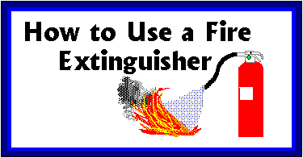

It's easy to remember how to use a fire extinguisher if you can remember the acronym PASS, which stands for Pull, Aim, Squeeze, and Sweep.
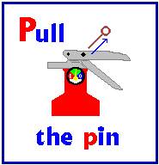 | Pull the pin.  This will allow you to discharge the extinguisher.
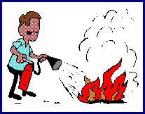 | Aim at the base of the fire.  If you aim at the flames (which is frequently the temptation), the extinguishing agent will fly right through and do no good. You want to hit the fuel.
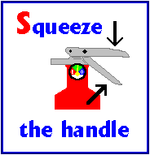 | Squeeze the top handle or lever.  This depresses a button that releases the pressurized extinguishing agent in the extinguisher.
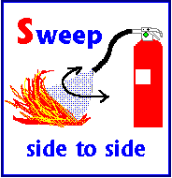 | Sweep from side to side  until the fire is completely out. Start using the extinguisher from a safe distance away, then move forward. Once the fire is out, keep an eye on the area in case it re-ignites.

Test Your Knowledge:
1 | An example of two "Class B" fuels would be:
 |  |  | Cardboard, newspapers
 |  |  | Lamp, hot plate
 |  |  | Grease, paint thinner
2 | An APW (water extinguisher) is safe to use on an electrical fire.
 |  |  | True
 |  |  | False
3 | Carbon Dioxide extinguishers are designed for which types fuels?
 |  |  | Class B and C
 |  |  | Class A, B, and C
 |  |  | Class A and C
 |  |  | Class A and B
4 | Which type of extinguisher has a hard horn on the end of a flexible hose or metal arm?
 |  |  | APW (Air Pressurized Water)
 |  |  | CO2 (Carbon Dioxide)
 |  |  | ABC (Dry Chemical)
5 | As a general rule, you should not attempt to fight a fire if it is spreading rapidly.
 |  |  | True
 |  |  | False
6 | ABC fire extinguishers extinguish fire by cooling it down.
 |  |  | True
 |  |  | False
7 | Water will not extinguish most flammable liquid fires.
 |  |  | True
 |  |  | False
8 | You should always keep an exit or means of escape at your back when trying to fight a fire.
 |  |  | True
 |  |  | False
9 | The three elements of the fire triangle are:
 |  |  | Water, a heat source, and fuel
 |  |  | Oxygen, water, and fuel
 |  |  | Oxygen, fuel, and a heat source
 |  |  | Fuel, oxygen, and earth
10 | Do you know where the nearest fire extinguisher is in your work area?
 |  |  | Yes
 |  |  | No

