Rules and Regulations

from: http://www.robotroom.com/index.html

1. Overview
Two autonomous robots are placed in a ring. The robots try to avoid falling out or being pushed out by the opponent. The first robot that touches outside of the ring loses the round.
The first robot to win two rounds, wins the match. Robots compete one-on-one against each other throughout the contest. The robot that wins the most matches wins the contest.

2. Robots
Autonomous Sumo robots are self-propelled and self-controlled, without tethers.
After positioning and starting the robot, no remote control, power, positioning, or other help can be provided. The robot must care for itself until the round ends. As long as all other requirements are met, Sumo robots can be made out of any material. They can use any type or size of electric motor or electric-powered locomotion. They can contain any kind of processor, electronics, sensors, or batteries desired.

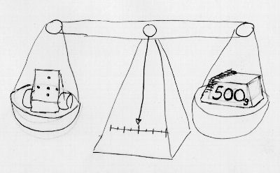
2.1 Mass
Mini-class Sumo robots may have a mass of 500 grams or less.
Lift can’t reduce the robot below the required limit because the limit is specified in mass (universal constant) rather than weight (gravity component). For example, a helium-filled balloon can’t be used to lighten a robot during weigh in.

Because this is a pushing contest, it is to the robot’s advantage to be as heavy as possible.

Extra weights or washers may be used to increase the robot’s mass to the maximum amount as measured at the contest location.

2.2 Dimensions
At the start of each round, Sumo robots must not exceed a specified width and depth.
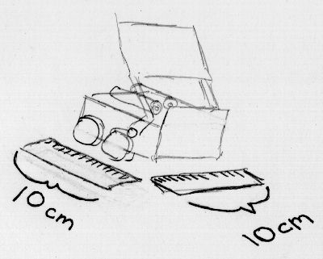
Mini-class Sumo robots may be 10 centimeters or less in width and 10 centimeters or less in depth.
There is no height limit to either class. Also, as soon as movement is allowed in a round, the robot may then twist, fall, or expand without size limits.

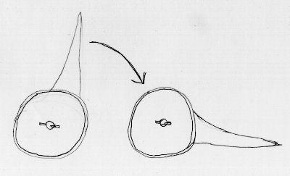
2.3 Taking Advantage of Height
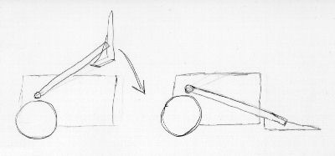
The lack of a height limit is important to some builders, as they may stack up electronics, motors, and other parts that wouldn’t otherwise fit. The lack of a height limit combined with the ability to change orientation during a round provides for creative opportunities. Crafty inventors build tall scoops atop their robots. The robots then fall down to make themselves longer than would be initially allowed. Some robots tip only their scoops into position, rather than dropping the entire robot.

2.4 Harmlessness
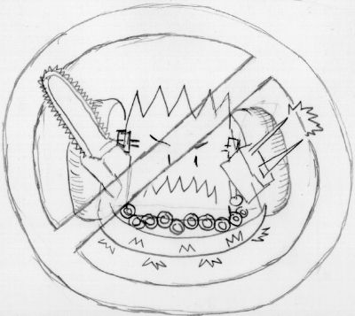
At all times, robot behavior must be non-offensive, non-destructive, and non-harmful to humans, robots, and the facilities. This is an immutable principle, even if the behavior is unintentional or not by design. During inspection (and at any time during the event), the judges may require safety changes or other modifications to meet the harmlessness requirement. Harmful robots are either not allowed to compete at all or are later disqualified if harmful issues are proven or revealed in battle.
At all times, Sumo Robots must not: Emit smoke or fire; Leak, stain, or soil; Disperse powder, grit, or grime; Spray, throw, or use projectiles; Jam, shock, or electromagnetically interfere; Snare, entangle, or employ nets/rope; Scratch, gouge, or scrape. Sumo Robots must not fly or generate lift to isolate themselves from the ring surface. Jumping is permitted.

3. The Ring
The Robot Sumo ring is a large, flat disc. It is made of a smooth, rigid material, such as wood, aluminum, or steel. The top is usually painted or made of hard rubber. The top surface is dull black, except for a thin border that is shiny white. Two starting lines in the middle are brown. All of these areas are “in” bounds.
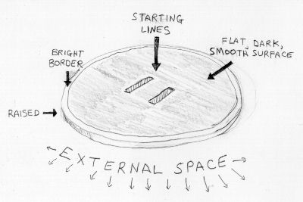
The ring is raised slightly to make it easier to determine when a robot has been pushed out. The height isn’t very much though, to avoid damaging robots that fall or get pushed out.
An external area of at least 100 centimeters of empty space exists around the ring. This space must not contain any people, objects, lights, or anything else that would distract or interfere with the robots. The floor may be any color but white.

3.1 Edge Sensors
A surprising number of Sumo robots drive out of the ring without even being pushed. A well designed and built Sumo robot should be able to navigate the ring indefinitely without falling out. The flat black ring surface contrasts with the gloss white border so that a robot can easily use a light sensor to detect the edge. Physical switches can also be used to detect ring edges.

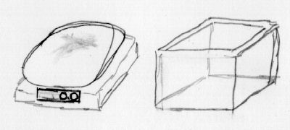
4.1 Inspection
Each robot is measured and inspected to verify qualification. Allow for a little free weight that can be added or removed in case your home scale doesn’t match the tournament’s scale.
For width and depth, a carefully measured box or cube is placed over the robot. Actually, the box is more of a tube really, because it is missing the top and bottom. The box avoids arguments over ruler interpretation, because the robot qualifies if the robot fits in the box. The robot must start each round of the contest in an orientation and physical position that would fit in the box. It would be unfair to measure the robot in one position (sticking out of the top of the box) but then manually rotate the robot to an unqualified length before beginning a match.
The robot is inspected to be sure it is non-damaging and generally safe. Robots may be altered between rounds and matches, either for repairs, battery changes, or reconfiguration. Keep in mind that the referee may re-examine the robot at any time to re-verify qualification.
4.4 Playoffs
Double Elimination: Upon losing two matches, the robot is out of the contest. This is common practice when a large number of robots are entered. A good way to run a double-elimination playoff is to have the set of winning robots pitted against other winning robots, and losing robots against losing robots. That way, a robot won’t have the bad fortune to compete against two top robots in row.

4.6 A Match
At the beginning of a match, the contestants approach the ring and bow to each other. The robot must be ready at the appointed times. Contest organizers may grant reasonable leeway, but a referee may declare a round or entire match lost if a robot isn’t punctually prepared to compete. Throughout the contest, the algorithms, settings, and components on the robot can be shaped, angled, or configured differently for facing each opponent and being placed in different starting positions. In some contests, although a reasonably identifiable core must remain, whole pieces may even be added or discarded. However, these changes must bear in mind appointed time constraints and class restrictions.

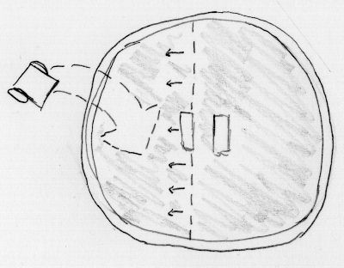
4.6.1 Positioning
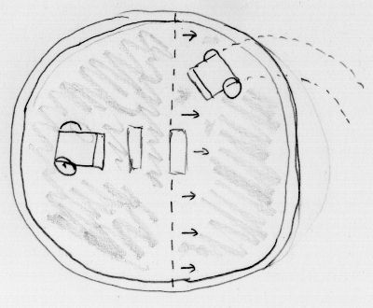
The robot that just lost the prior round is positioned first (or coin toss if first round). The contestant may place his or her robot in any position, angle, or location on the ring except that no portion of the robot may cross the extended starting line nearest the contestant. The robot that just lost the prior round is positioned second.
It is an advantage to be the second contestant to place a robot in the ring, so one shouldn’t forget or dismiss this opportunity. By placing the second robot out of the direct line of sight, at sideswiping angle, or closer/further to the first robot, it may be possible for the second robot to gain a quick victory. Depending on who wins this round, the order may change in which the robots are placed next round. The second contestant may place his or her robot in any position, angle, or location on the ring except that no portion of the robot may cross the extended starting line nearest the contestant. By the way, after the initial placement of the first robot, it isn’t permissible to alter its starting position. Even though this may be desired in reaction to the placement of the second robot!
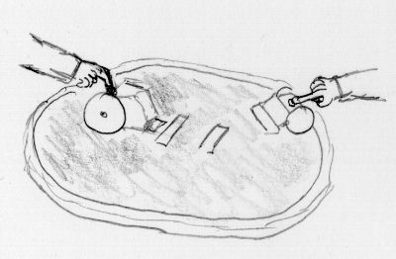
4.6.2 Ready? Set? Go!
A robot is usually started by pressing a button. However, a robot may be started by any means, such as hand clapping, a whistle, RF signal…. Robots may even have multiple starting buttons or starting configurations if designed with more than one opening move. (Upon starting, no additional control, commands, configuration, or information may be communicated to the robot.)
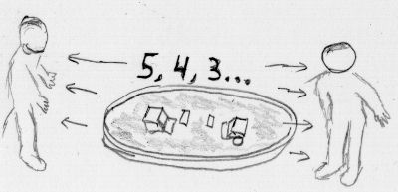
Both contestants place their fingers on their robot’s starting buttons and await the referee’s signal. If a problem is encountered before the referee says, “go”, a contestant may alert the referee, without penalty, that the robot isn’t ready. (Commonly, a robot may fall or slip when a finger is place over the start button.)

4.6.3 Clear Exterior
Upon pressing the start buttons, the contestants immediately leave the exterior area around the ring. During the round, all people and objects must be kept out of the ring and exterior area to avoid distracting the robots or altering the outcome.
Upon pressing the start buttons, each robot must not move at all for five seconds. However, countdown lights, buzzers, sounds, or other entertaining motionless activity is encouraged.
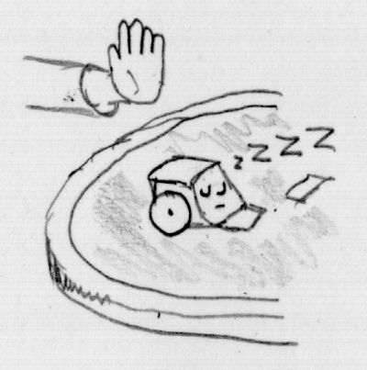
4.6.4 No Start
During the countdown, if the contestant notices their robot has failed to start its countdown, the contestant may alert the referee and halt the countdown. Both robots are reset to start the round over. The contestant is given a warning. A second warning in a single round results in a loss.

4.6.5 False Start
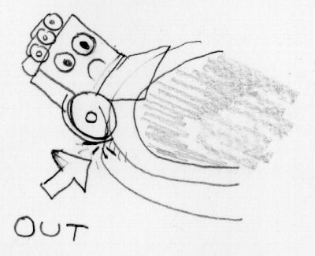
If a robot begins moving during the five-second period, the robot has committed a false start. A warning is issued and both robots are reset to start the round over. A second warning of any kind in a single round results in the robot losing that round. Designers may be tempted to program a countdown timer that is shorter than the five seconds required. However, referees and competitors quickly catch this, which results in warnings followed by round loss after round loss for the cheat.

4.6.6 Out
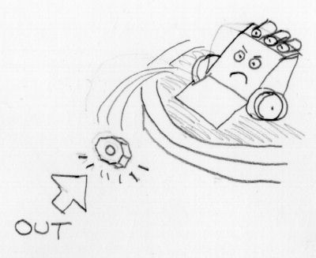
A robot loses a round when any portion (including touch sensors, whiskers, scoops, or skirts) of the robot touches outside of the ring. It doesn’t matter if the robot falls out on its own or is pushed out. The first robot touching outside of the ring loses, even if the second robot subsequently touches outside of the ring. If the referee determines that both robots touched outside of the ring at the same time, the round is nullified and started over.
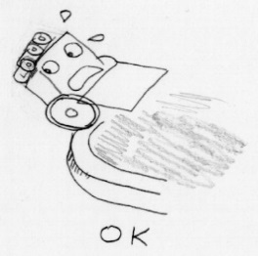
If any piece of the robot, no matter how small or even if detached, touches outside of the ring, the robot is considered out. For example, if a nut drops off a robot within the ring, the robot doesn’t immediately lose. However, if the nut is then pushed out or rolls out, the robot loses.

4.6.7 Not Out
Starting to fall or breaking the plane of the ring isn’t considered out. Some portion of the robot must actually touch outside the ring.

4.6.9 Referee Stoppage
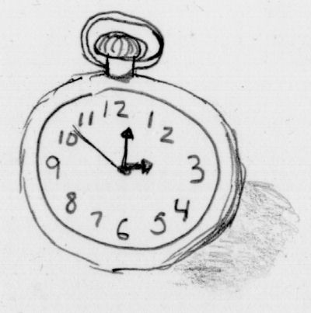
At the referee’s discretion, the referee may choose to restart a round if:
- Three minutes have expired
- No progress has been made in some period of time
- The robots fail to touch each other for some period of time
- The robots are hopelessly entangled or otherwise deadlocked
- Both robots fail to start or both contestants signal stoppage
At the referee’s discretion, the referee may choose to end a round and choose the round winner if:
- Smoke, fire, damage, or any other violation has occurred
- No progress is likely to be made even if the round is restarted

4.8 End Of Round
At the end of a round, contestants retrieve their robots and prepare for the next round.

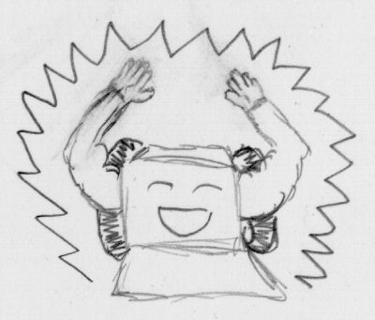
4.9 End Of Match
The first robot to win two rounds, wins the match. This means there can be as few as two very quick rounds to win a match. Or there can be as many as three, three-minute rounds (not counting restarts). In the latter case, each robot must have won a round to force the third-round tiebreaker. Of course, a match may also end if a contestant or robot is disqualified or otherwise unable to complete. At the end of the match, the contestants bow to each other, just as they did at the beginning of the match. They then leave the ring area to prepare their robots for any additional matches in the contest. A happy robot is a winning robot

5. Tips
- When two well-built robots compete, the tires become the deciding factor. The better the tires grip the ring surface, the more the robot can shove and the less the robot can be shoved. Unless severely underpowered, motors rarely stall; almost always the tires spin. Narrow, worn tires spell disaster. Wide, clean, abundant tires spell victory.
- A scoop or arm is vital. Anything that shifts the opponent’s weight of off its wheels is desirable. A scoop can both reduce the grip of the opponent’s wheels (by tilting weight off) and also increase the grip on the scooper’s wheels (by tilting the opponent’s weight on top). Also, a scoop may topple or tip an opponent onto its side or over the ring edge.
- Dark robots are more difficult for the opponent’s infrared or light sensors to see. Fuzzy-surfaced robots are more difficult for sonic sensors to detect.
- Slick, encased robots are more difficult for the opponent to grip or damage.
- Although not required, infrared or other opponent-targeting sensors improve a robot’s chances of contacting the opponent in a motion with the greatest forward momentum. Additionally, a robot with opponent sensors is less likely to get struck from an undesirable angle, such as on the side or from behind.
- Because of human nature, rounds usually begin with the robots positioned facing each other. If they miss each other on the first pass, the round may take some time. The longer the round takes, the more likely the robot with good edge sensors is likely to win by default as the robot with poor edge sensors simply drives out of the ring.

6. Spirit
Based on fair competition, Robot Sumo encourages friendships and the exchange of ideas, showcases accomplishments, advances robotics, and seeds interest in future generations of robot builders.

and most importantly, ... have

