Several students have inquired about sizing. I know it is a challenge to order clothes without trying them on, but unfortunately, trying them on is not a possibility. With that being said, I found the following information from the clothing lines websites. Although I do not know what these charts mean, hopefully it helps you. I have included the websites to find more information on the grad items.

Baseball t-shirt

https://www.sanmarcanada.com/pdfs/ATC_S3526.pdf

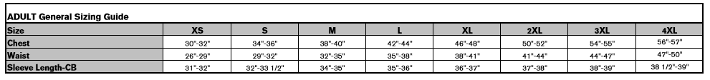

Hoodie

https://www.bizcollection.ca/ca/products/sw239ml

