February 2, 2023

Dear ASD-N High School students and families,

Over the last few years, the Department of Education and Early Childhood Development has been working to improve the high school experience. This work has been informed by feedback from students who shared that they want more choice, more flexibility, and more relevance in their course selection.

As a result, High Schools are introducing several changes that will begin with students entering Grade 10 in the 2023-2024 school year, which include:

- Grade 10 students will now receive credits towards graduation for their course work
- A course will now be worth 4 credit-hours
- Students, in consultation with their school and family, can apply for early graduation once they meet graduation requirements

Course Selection

Starting in September 2023, all students in Grades 10 through 12 will accumulate credit hours. This means, during the second semester, Grade 9 students will join Grade 10 and 11 students in course selection for the next year.

Students will still have compulsory courses, but more choice will be offered in subject areas such as English, Math, Science, Humanities, Career, Art, and Physical Education. As this will result in Grade 9 students having more options, future learning and career goals will be important to consider. With the support of teachers and guidance counsellors, students will have the opportunity to begin developing career-life plans in the digital career and life planning tool myBlueprint.

Credit Hours and Graduation Requirements

Under the current system, students are assigned a credit on the completion of a course. Going forward, a completed credit will be assigned four credit hours. (i.e., one course = four credit hours).
Those entering Grade 9 or 10 in 2023 must complete the following to apply for graduation:

- successfully complete Grade 9
- complete compulsory courses in Grades 10 through 12
- accumulate 100 credit hours to apply for graduation
- meet the requirements for the English Language Proficiency Assessment
- develop a career-life path in myBlueprint

Students will also be required to meet any requirements of their desired post-secondary program.

Students currently in Grade 10 and 11 will only be required to obtain 72 credit hours (equivalent to the 18 credits under the current system). Beginning in January 2024, all students will be able to apply for early graduation once they have met graduation requirements. Students currently in Grade 12 who are graduating in June 2023 will only be required to obtain 18 credits under the current system

to meet graduation requirements.

An Updated High School Experience

It is our hope these changes will result in a high school experience that offers students more choices, more flexibility, and more relevant options to help them prepare for life after high school.

EECD, in collaboration with ASD-N, will be offering an information session for families and students to learn more and ask questions on Wednesday, February 22 at 6:30pm. The link to that meeting is here at ASD-N Parent Meeting.
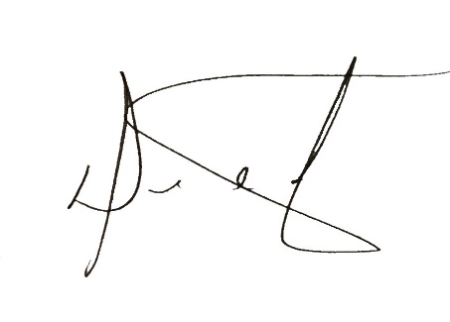
Sincerely,

Dean Mutch
Interim Superintendent
Anglophone North School District

