What is the N.E.A.T. Committee?
The N.E.A.T. Committee is made up many members from MVHS, Eel Ground, Human Resources, Esgenoopetitj, and Metepenagiag. This committee is designed to help and support Native youth educationally and spiritually in a culturally relevant way. One of the ways we do this is by administering a survey for the youth to fill out at the beginning of the year. From the data collected we as a team develop strategies and pursue funding to enact programs that will help the youth.

New Resources:
The NEAT committee would like to introduce the following additions to the MVHS team.
Jeannie Bartibogue: Taking on the position of First Nation Student Counselor and Cultural Advisor, Jeanie previously held the position of Aboriginal Student Advisor at NBCC Miramichi. She has been working with youth for as long as she can remember and is pleased to join the MVHS team.
Jennifer Dedam: Taking on the position as First Nation Guidance Counselor. She has been a teacher in Burnt Church for 30 years and also has done work with special resources.

Attendance:
Attendance is a major issue, not only with our First Nation students, but all of our students. It is very important to have good communication between the school and parents. One way to do this is to call Jeannie or Jennifer to inform them of problems a student maybe having with attendance or otherwise.
At the beginning of each year a student is sent home with an information collection sheet, which asks parents and/or guardians to clarify contact information. This is important to complete because when the school needs to contact you about something they can.
Good attendance is directly linked to student success!
Also, each incoming grade 9 student will be sent home with a “First Nation Student Hand Book”, which describes parents learn how they can get involved in their child’s education. This handbook will explain how you can support your child’s education by volunteering, and what to do if you are concerned about your child.

Members: Scott Jamieson, Matthew Sweezey, George Ginnish, Anne Marie Larry, Victoria Ginnish, Hazel Francis, Cheryl Ward, Karen Atwin, Byron Bushey, John Hawkes, Jeannie Bartibogue, Karen Somerville, Jennifer Black, and Simon Dedam. Youth Memebrs: Hunter Francis, Athena Francis, Tanner Cloud, and D.J. Kingbird.

Existing Resources:
Matthew Sweezey: Methods and Resource Teacher for First Nation students.
Vicki Ginnish: Eel Ground First Nation Student Liaison
Cheryl Ward: Eel Ground First Nation Youth Programs & Service Coordinator

Activities and Events:
Native Cultural Awareness Week:
Miramichi Valley High School (MVHS) had its second annual Native Cultural Awareness Week from May 22-25. It demonstrated the rich history and culture of the Mi’kmaq First Nation. The week was an overwhelming success and even drew the Aboriginal Healing Network Foundation, which brought the “Legacy of Hope” exhibit. This exhibit shed light on the 100 years of loss that impacted First Nations across Canada because of residential schools. Former MP and Minister of Aboriginal Affairs, Andy Scott, also participated during the week. Scott said, he believes students should be learning about Residential Schools and their Impact in the classroom.
Each day consisted of a new activity for students to participate in beginning with the “Legacy of Hope” Exhibit presented by Gail Paul, Teachings on the Sacred Fire & Traditional Honor Song by Doc Francis and Robert J Louis, Arts and Crafts, Baskets and Regalia by Vicki Ginnish, Jackie Somerville, Jane Simonson, and Delta Augustine, Intro. On Medicine Wheel by Jeannie Baritbogue, and on the last day a Traditional Feast. The organizers would like to thank all the student volunteers that made this event possible; thank-you.
North and Esk Regional High School (NSER) had their inaugural Native Cultural Awareness Mini Pow Wow on May 23 and a feast on the 24th. NEAT Committee member and Native Education Support Worker at NSER, Jennifer Black, worked tirelessly to organize this event, which was a raging success attracting the likes of, Andy Clark who is District 16’s Acting Director of Education, Chief Freeman Ward, and some Metepenagiag councilors. The Mini Pow Wow was much like a Pow Wow you would see in your own community. The event was emceed by Derek Barnaby and the Thunder Eagle Drum Group provided the heart beat of the dancing, which included a men’s traditional dance by Derek Barnaby, Chris Wysote, Joe Barnaby, and the Metepenagiag School Dancers, a medicine dance by Ingrid Brooks, and Lisa Levi, a fancy shawl dance by Esgenoopititj Wegatusgk Dance troupe, women’s traditional dance by Victoria Augustine and the Metepenagiag School Dancers. The event was open and closed by a prayer from elder Joseph Leonard Ward.
BOTH CULTURAL AWARENESS EVENTS WOULD LIKE TO THANK ALL THOSE RESPONSIBLE MAKING THE EVENTS SUCH A SUCCESS. THESE EVENTS COULD NOT BE DONE WITHOUT THE HARDWORK AND DEDICATION OF MANY VOLUNTEERS AND DONORS. THANK-YOU!!!!!!!

Awards and Acknowledgements:
Kendra Dedam, from Esgenoopetitj (Burnt Church), participated in the Encounters with Canada program where she received an award for participation.
Ryan Hogan, from Eel Ground, was the recipient of the MVHS Unsung Hero, Most Valuable Member for Student Council, Male Music Award, Drama Club Unsung Hero Award, and the “M” Award.
Kelsey Larry, from Esgenoopetitj (Burnt Church), received the Special Needs Participation Award.

June Birthdays: Canyon Barnaby, Tanisha Barnaby, Hilton Dedam, Kendra Dedam, Tomaz Dedam, Matthew Joe, DJ Kingbird, Matthew Larry, Kyla Martin, Denise Savoie, Brenda Simon, Elijah Somerville, Kelsey Ward, Zachary Ward, Muin Young.
July Birthdays: Shelby Dedam, Jessica Fournier, Roman Francis, Shania Joe, Allison Martin, Dustin McKay, Dane Paul, Kolby Simonson, Jade Somerville, Jason Somerville, Dylan Ward.
August Birthday: Brandon Augustine, Marilyn Dedam, Dana Richardson, Shania Simoneau, Sacha Simonson, Alex Somerville, Elliot Somerville, Rain Somerville, Brianna Ward, Daisy Ward.

2012 M.V.H.S Graduates: Esgenoopetitj (Burnt Church)- Sofie Allain, Houlton Bonnell, Kiana Bonnell, Felicia Dedam, Kelsey Dedam, Kendra Dedam, Shahila Francis, Jessie Larry, Shawn Larry, Allison Martin, Brittany Martin, Melissa Martin, Curren Metallic, Alanna Mitchell, Lance Narvey, Celina Paul, Aaron Robichaud, Rain Somerville. Connor Ward, and Matthew Ward.
Eel Ground- Nigel Augustine, Allanah Denny, Ryan Hogan, Matthew LeBlanc, Melissa Simon, Kelsey Simon, Sacha Simonson, and Allison Ward.
Metepenagiag- Tanner Cloud, Pauline Norton-Paul, Riley Patles, and Tanner Ward.
Duke of Edinburg’ Award: An award worth applying for any youth with commitment & determination to achieve their highest potential.
http://www.dukeofed.org/nb/onlinereg

MVHS Native Cultural Awareness Week
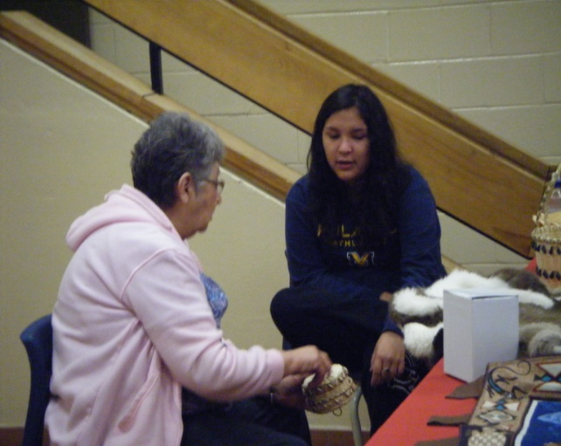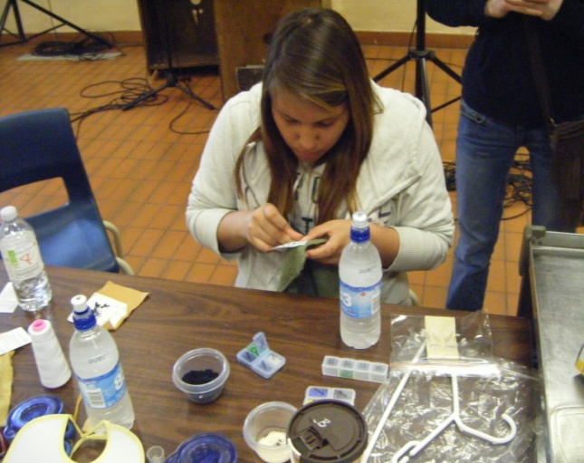
Jane Simonson and Allison Martin of Esgenoopetitj learn about basket making.
Hayley Sark, from Eel Ground, beads during Native Cultural week.

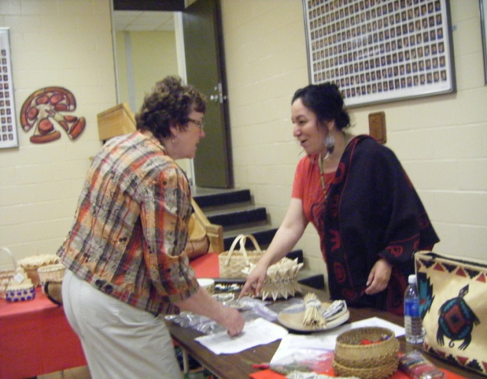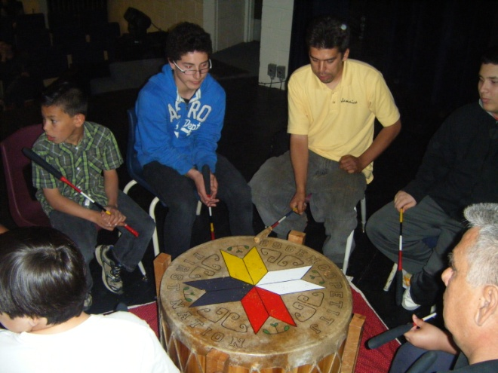
Jeannie Bartibogue and MV teacher Sheila Carroll talk about traditional medicine.
The Esgenoopetitj Red Eagle Drum Group and student Robert Louis of Esgenoopetitj perform during the opening ceremony of the “Legacy of Hope” exhibit.

