AT MVHS, we are proud to present our 2014 Winter/Spring Carnival. This event is brought to you by the staff of MVHS as well as the MVHS Student Council. AT MVHS, we believe that community and being a good citizen is essential, and this event brings all of those beliefs together. We hope you take advantage of all of the activities organized for our students, and that you enjoy yourself. First prize is a meal and movie. Below, you will find the event time, details of the week, and a map of events. If you have any questions, please ask your homeroom teacher, Mr. Valanne or Mr. Jamieson.

Monday, March 17th, 2014
Dress up theme: Saint Patrick’s Day. To celebrate the spirit of the Irish, students are to dress in green and orange and wear any other Irish bling.
Noon hour activity: Student council will organize a spirit event to celebrate the End of Winter Week.
IS Event: Homeroom classes will meet during IS time to participate in our first team event. Whole team participation is encouraged. The event will take place in homeroom classes. Computer and Smart board will be needed.
Tuesday, March 18th, 2014
Dress up theme: Red Neck/Hat Day: Everyone will be Happy ,Happy, Happy! Dress in your best camouflage outdoor wear or wear a hat for a change.
Noon hour activity: Duck Dynasty Style Rock, Paper, Scissor Tournament (cafeteria 12pm). Each class elects one member to partake in a Pellet, Bread and, Duck single elimination tournament. 1 member is needed per team.
IS Event: Students can work with their team to prepare for the week.
Evening Event: Movie Night (Theatre). Event starts at 7 pm. Cost is 2 dollars. Movie to be named later. A canteen will also be available.
Wednesday, March 19th, 2014
Dress up theme: Sports Jersey Day. Live as your sport hero, if only in your mind. Any jersey will do.
Noon hour activity: Surprise. (Cafeteria 12pm) We will need one male and female member to participate in this event. We will give you the details at event time
IS Event: Students can work with their team to prepare for the week.
There will also be an information session for all students taking or interested in taking shop courses in the theatre concerning the pre-apprenticeship program.
Evening Event: ASD-N presents, the CUTE (Creative Use of Technology) Awards will take place at the JMH theatre at 6pm)
Schedule and Details for Friday, March 21st, 2014
8:30-8:45 Students will go to their Homeroom class
8:45-9:20 Opening ceremonies/ Presentation of teams
9:30-10:30 Session 1
10:40-11:40 Session 2
11:40-12:20 Lunch
12:20- 1:20 Session 3
1:30-2:30 Session 4
2:30-3:20 Closing Ceremonies
4:00-7:00 Shaker

9:30-10:30 Session 1
Venue 1 (outdoors) Group 1
Venue 2 (Theatre and Cafeteria) Group 2
Venue 3 (Pool and Mez) Group 3
Venue 4 (Gym) (variety show) Group 4

10:40-11:40 Session 2
Venue 1 (outdoors) Group 2
Venue 2 (Theatre and Cafeteria) Group 3
Venue 3 (Pool and Mez) Group 4
Venue 4 (Gym) (variety show) Group 1

12:20- 1:10 Session 3
Venue 1 (outdoors) Group 3
Venue 2 (Theatre and Cafeteria) Group 4
Venue 3 (Pool and Mez) Group 1
Venue 4 (Gym) (variety show) Group 2

1:30-2:30 Session 4
Venue 1 (outdoors) Group 4
Venue 2 (Theatre and Cafeteria) Group 1
Venue 3 (Pool and Mez) Group 2
Venue 4 (Gym) (variety show) Group 3

Group 1 Group 2 Group 3 Group 4

- T. Stewart/S. Casey S. Shannon O’ Neill-McDonnell M. Maltby-Ingersoll
- N. Sherrard S. Boone D. Richard E. Kelly
- T. Whalen J. Howe J. Manuel/M. LeBlanc C. Matheson/B. Cameron
- G. Bruce/B. Mutch K. Sears M. O’Donnell B. Savage
- P. Kingston T. Holland/K. Dickson A. Bowes/E. Walker/K. Girouard S. Daley
- A. Pleadwell R. Innes/ M. Stewart K. Cripps/R. Stewart K. Cable

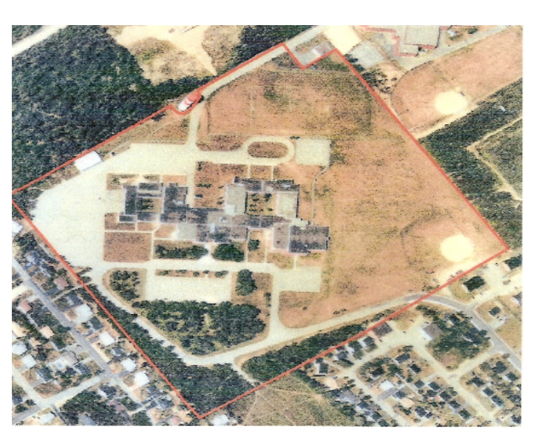
We hope that everything will run smooth and enjoyably. Take advantage and have fun. Good luck to all teams. Attendance will be taken throughout the day at each session. Attendance counts towards academic incentives and school attendance. In order to attend the shaker, students must be present during all sessions and check- ins. Students will be given a ticket for the shaker at some point on Friday, March 21st. Tickets must be presented at the door to attend the shaker.

The Variety Show scheduled for Thursday night will now take place throughout the day on Friday. Teams will present their act when they are schedule for the gym activities..

