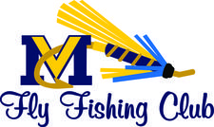
Youth…Post Your Bass Photo Contest!
Miramichi Youth Fly Fishing & Sportsman Programs

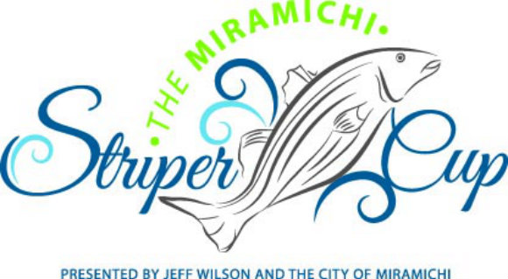

DETAILS: The schools that participated in our Fly Fishing Workshops
this year are encouraged to have their students
participate in the Miramichi Striper Cup…youth under 16
years of age are free while over this age costs $20 with a
chance to win the door prize. All catches have to be
documented in order to get in on their prizes.
Visit their website for further rules and regulations…
http://www.miramichistripercup.ca/
CONTEST: We would like to populate our Facebook page with your
pictures too! As an added bonus prize, we will be
drawing for a Bass Fishing Rod/Reel/Tacklebox/Gear
for youth who share their pictures on our Facebook
site… ‘Miramichi Youth Fly Fishing Programs’. All
submissions will be entered for the draw.
WHEN: Saturday, May 30th & Sunday May 31st
HOW: 1) Take photo of you with your bass
(include name of student/school in the post)
2) LIKE our Facebook site
3) SHARE photo by posting to our page
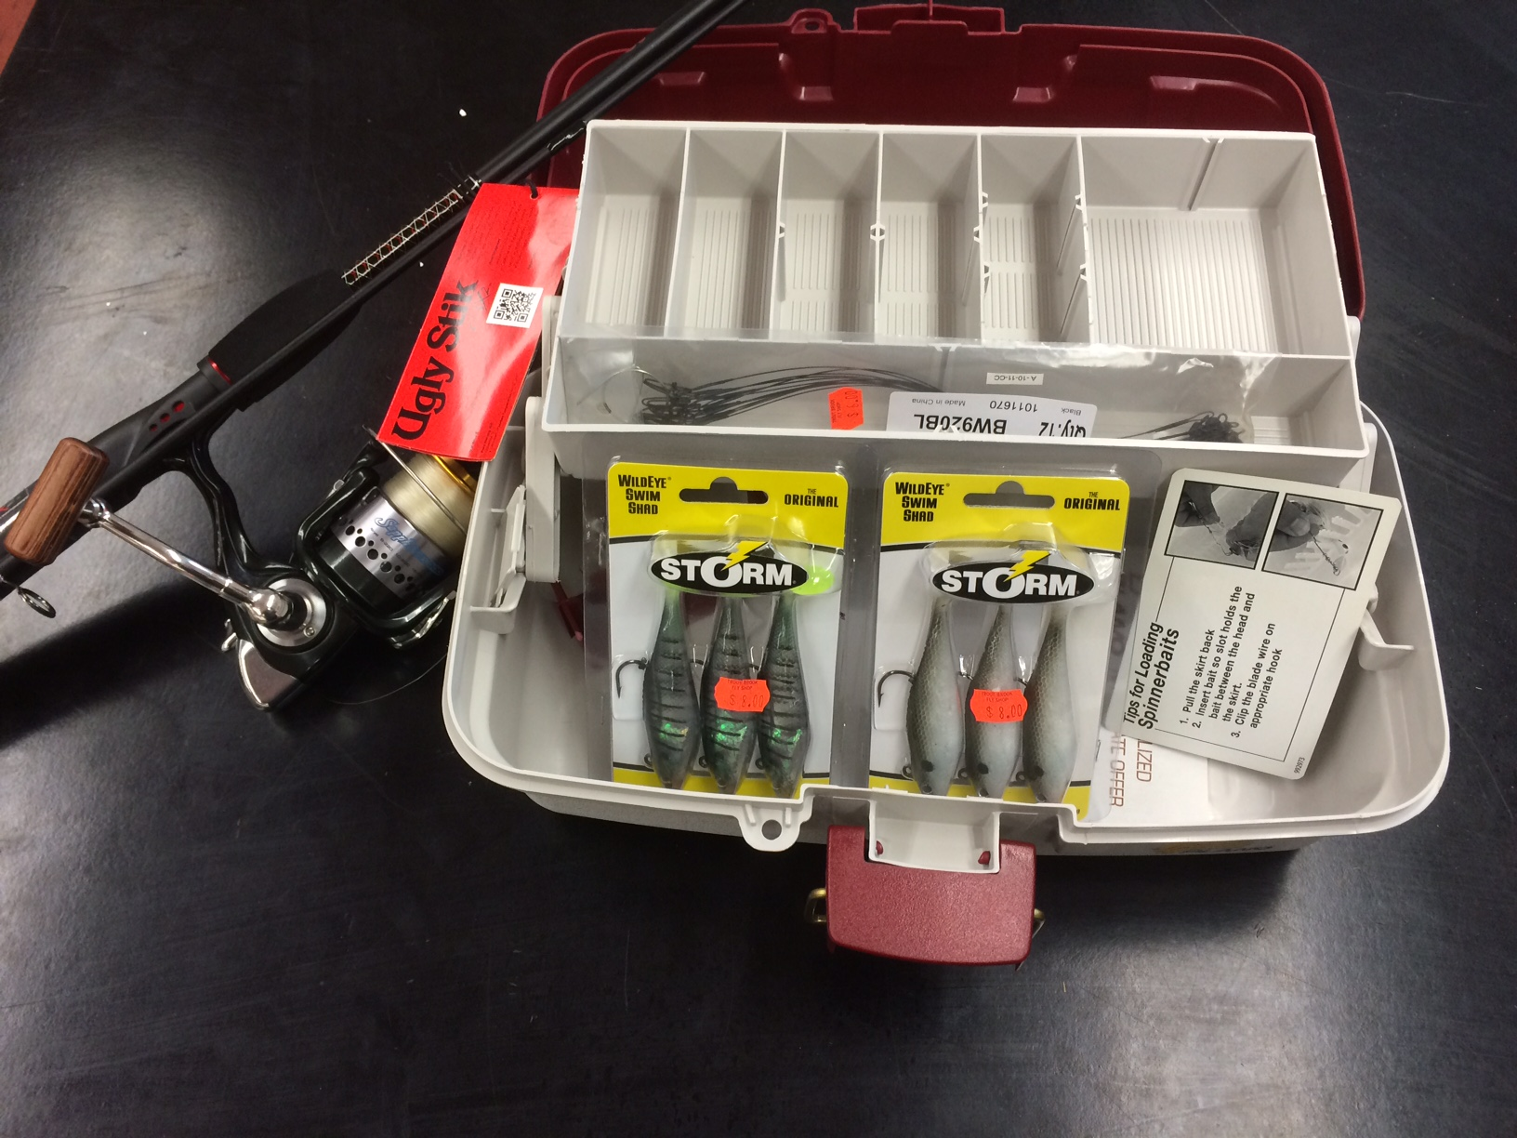
WIN
THIS
PRIZE!

