MVHS ALUMNI HOMECOMING DAY
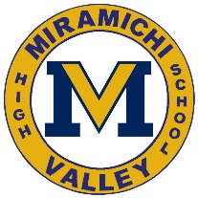
ALUMNI
Saturday, October 22, 2016
10 am-1:00 pm
Pre-Game
Jumping Castles
Games
Face Painting
Green’s Catering Food Truck
MVHS Merchandise for sale

1:00 pm
Football Game
MVHS VS. JMH

9pm-1:00am
Homecoming Dance hosted by MVHS Alumni Association
Tickets $10 available at N&J Convenience, PHARMASAVE Newcastle and MVHS
Adults 19+ All are Welcome (not just Alumni)

