Show them how proud you are!
Purchase a personal ad for your graduate
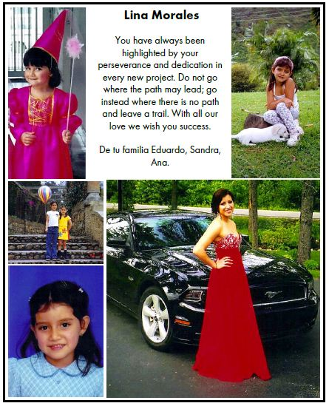
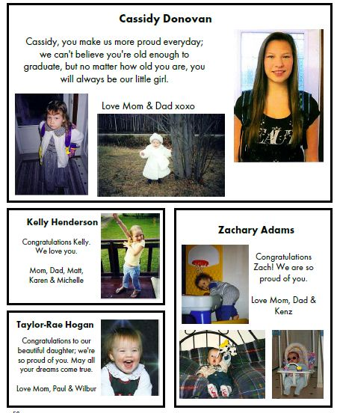

½ Page ad ($90.00)

_{1/8} page ad ($35.00) ¼ page ad ($65.00) Full page ad ($150.00)

The MVHS Yearbook Committee invites you to purchase space in the 2017 yearbook for that special graduate in your life. The ad will appear in full colour!

What are personal ads?
Traditionally, these have been called “baby ads”, but the Yearbook Committee have been calling them “personal ads”, as we encourage you to choose pictures of your child at any age. Some of the most effective ads have included informal photos of students in their grad year.

How do I purchase a personal ad?
If you wish to purchase a personal ad, simply fill out the back of this form and return it with payment to Krista Cabel at MVHS on or before December 23rd. Cheques can be made payable to “MVHS Yearbook”.

How do I deliver the pictures?
Digital pictures can be emailed to Krista Cabel at krista.cabel@nbed.nb.ca. Hard copy pictures can be passed in with the form and payment. They will be scanned and returned to you at a later date.

Student Name: ______________________________________________________

Parent Name: _____________________________ Parent Phone #: ______________________
Parent e-mail:________________________

Personal ad pricing:

Full Page Ad $150
1/2 Page Ad $90
1/4 Page Ad $65
1/8 Page Ad $35

Indicate the size of ad you would like to purchase: ________________

Please write a message to be included with the graduate’s ad:

__________________________________________________________________________________________________________________________________________________________________________________________________________________________________________
__________________________________________________________________________________________________________________________________________________________________________________________________________________________________________
______________________________________________________________________________

If you would like the ad to be designed in a specific way, please sketch it below:

