25th Annual Miramichi Hoop Classic

Girls Schedule

Girls Teams
Miramichi Valley High School (MVHS)
James M. Hill High School (JMH)
Rothesay High School (RHS)
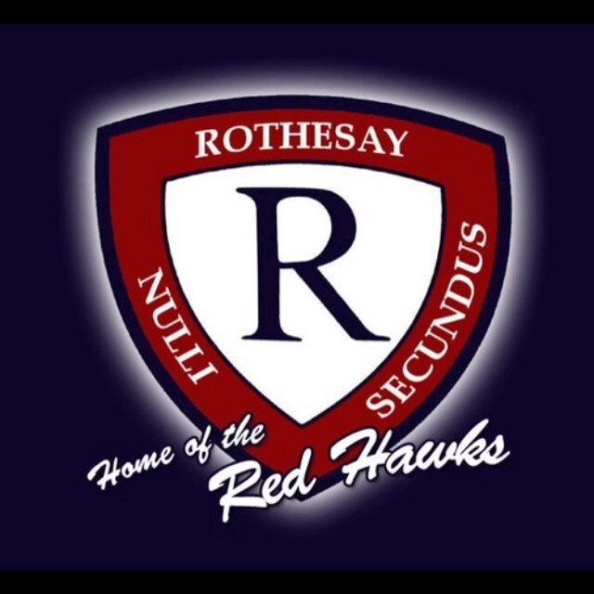
Saint John High School (SJHS)
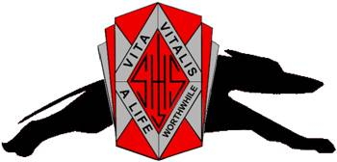
Carleton North High School (CNHS)
John Caldwell School (JCHS)
Leo Hayes High School (LHHS)
Woodstock High School (WHS)

Boys Teams
Miramichi Valley High School (MVHS)
James M. Hill High School (JMH)
Amherst Regional High School (ARHS)
Fredericton High School (FHS)
Charlottetown Rural High School (CRHS)
Leo Hayes High School (LHHS)
Central Kings Rural High School (CHRHS)
Moncton High School (MHS)

Game | Date | Time | Guest | Home | Location
1 | Nov 17 | 11:30 | LHHS__ | MVHS__ | MVHS
2 | Nov 17 | 11:30 | WHS__ | RHS__ | Max Aitken
3 | Nov 17 | 11:30 | JCHS__ | JMH__ | JMH
4 | Nov 17 | 11:30 | SJHS__ | CNHS__ | Dr. Losier
5 | Nov 17 | 3:00 | L1____ __ | L2____ __ | MVHS
6 | Nov 17 | 3:00 | L3____ __ | L4____ __ | JMH
7 | Nov 17 | 6:30 | W1____ __ | W2____ __ | MVHS
8 | Nov 17 | 6:30 | W3____ __ | W4____ __ | JMH
9 | Nov 18 | 10:00 | L5____ __ | L6____ __ | Max Aitken
10 | Nov 18 | 10:00 | Consolation Final  W5____ vs W6____ |  | JMH
11 | Nov 18 | 12:00 | 3rd Place Game  L7____ vs L8____ |  | JMH
12 | Nov 18 | 2:00 | Championship  W7____ vs W8____ |  | JMH

Boys Schedule
Game | Date | Time | Guest | Home | Location
1 | Nov 17 | 1:15 | LHHS__ | MVHS__ | MVHS
2 | Nov 17 | 1:15 | MHS__ | CKRHS__ | Max Aitken
3 | Nov 17 | 1:15 | ARHS__ | JMH__ | JMH
4 | Nov 17 | 1:15 | FHS__ | CRHS__ | Dr. Losier
5 | Nov 17 | 4:45 | L1____ __ | L2____ __ | MVHS
6 | Nov 17 | 4:45 | L3____ __ | L4____ __ | JMH
7 | Nov 17 | 8:15 | W1____ __ | W2____ __ | MVHS
8 | Nov 17 | 8:15 | W3____ __ | W4____ __ | JMH
9 | Nov 18 | 10:00 | L5____ __ | L6____ __ | MVHS
10 | Nov 18 | 12:00 | Consolation Final  W5____ vs W6____ |  | Max Aitken
11 | Nov 18 | 12:00 | 3rd Place Game  L7____ vs L8____ |  | MVHS
12 | Nov 18 | 2:00 | Championship  W7____ vs W8____ |  | MVHS
Please Note:
- Friday games – 15 minute warm-up and 7 minute half time to keep the schedule on time.
- The schedule may be adjusted slightly since James M. Hill and Miramichi Valley will play all games on their home court where possible.
- Teams listed as the “home team” will wear light uniforms.

Score sheet provided by:

