Post-Advertising Advertising
The membrane separating advertising and content has been torn.
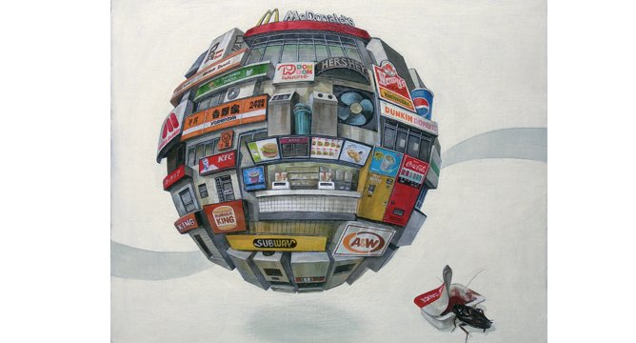
Masakatsu Sashie - Hoodia, 2007
“Oh America, I wish I could tell you that this is still America, but I’ve come to realize that you can’t have a country without people, and there are no people here. No my friends … this is now the United States of Zombieland.”

So begins one of 2009’s most surprising box office hits: Zombieland. Surprising not for its critical or commercial success, but for its complete absence of plot. If you haven’t seen it, here’s the gist: A group of Americans drive across the country in a shiny Cadillac Escalade in search of the world’s last Twinkie, killing zombies for laughs along the way. Oh, and they also watch Ghostbusters at one point, and two of them have a romantic interlude. Not so much a film, Zombieland is more a sequence of product placements wrapped inside a focus group-friendly pastiche. It definitely won’t win an Oscar, but its producers have achieved something far more valuable: a perfect blur of advertising and content.
The postapocalyptic premise of Zombieland is perfectly analogous to the current state of chaos that has devoured commercial media. The one-two punch of recession and internet growth has left advertising agencies and media firms alike limping to their doom, hemorrhaging funds and employees.
When the economy went to trash and profits tanked, everyone got really desperate and started to panic. The sacred membrane that separated advertising and content was torn apart. Ad agencies, desperate to prove their relevance to their corporate clients, climbed over the walls and spewed their infectious bile over all that was once holy. Print publishers and TV producers, frantic for any ad revenue they could get their hands on, gladly lapped it up. First went magazine covers, then newspaper covers. On April 9 a bankrupt LA Times ran a front page ad designed to look like a real article, prompting Times journalists to accuse their employer of “making a mockery of our integrity and journalistic standards.”
TV news was next. FOX brokered a deal that positioned McDonald’s iced coffee front and center alongside news anchors – a move that would have been deemed deplorable just a few years earlier. Within months the practice spread around the country and has since been dubbed “consum-o-tainment” by producers, who now offer advertorial services alongside legitimate news stories. But at that point, product placement was already omnipresent and news was just the final domino to fall.
In the first half of 2009 there were nearly a quarter of a million instances of product placement on US television. But this is just the beginning. Younger, up-and-coming media companies are starting to challenge the old media, and they are far more savvy and subtle when it comes to creating consum-o-tainment. Vice magazine, once the edgiest rag ever to top the Cassandra Report on teen marketing, now has its own in-house advertising agency. Similarly The Fader, a “super cool” music magazine, is backed by Cornerstone: a lifestyle marketing agency that specializes in band/brand cross promotion.
In order to compete with the likes of Vice and Cornerstone, ad agencies have also jumped on the consum-o-tainment bandwagon. Wieden + Kennedy, a Portland-based agency known for its slick and cinematic Nike campaigns, now has its own indie-centric online radio/TV hybrid: WKE.
The recession has proven ethics to be an expendable luxury. But rather than protest, audiences have largely met the shift toward branded media with a resounding shrug and accepted it as inevitable. In the near future – like this year – products will no longer just be “placed” but will become the focal point of entire films, documentaries and articles.
But perhaps this fin de siècle mediascape is a more accurate reflection of how we as consumers actually live our lives. Was the true focal point of our existence ever the love, heroism, drama or adventure we find in film and TV? Or is the truth much more banal, like the lives of the Zombieland characters who spend their days wandering through a wasteland of brands, watching Ghostbusters and searching for Twinkies?

Douglas Haddow

