New law makes tanning beds off-limits to most California teens
By Greg Botelho, CNN
updated 8:39 PM EST, Sun October 9, 2011
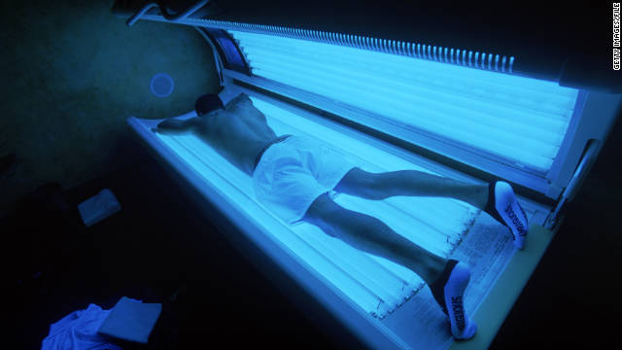
In 2009, the World Health Organization classified tanning beds as "carcinogenic to humans."
STORY HIGHLIGHTS
- California's governor signs a law barring those ages 14-18 from using tanning beds
- The law is the most restrictive of any state, though Brazil banned tanning beds altogether
- The bill's author says it will "help save lives and prevent unnecessary suffering"
- A WHO agency has classified tanning beds as 'carcinogenic to humans'
(CNN) -- California Gov. Jerry Brown signed into law Sunday a bill that prohibits most teenagers from getting bronzed in tanning beds, making the Golden State the first to do so.
State Sen. Ted Lieu said he first tried, and failed, in 2007 to make it illegal for people between the ages of 14 and 18 to walk into a facility and use ultraviolet beds to tan. Four years later, his effort finally paid off.
"I feel great," Lieu told CNN of the bill's passage. "I believe it will help save lives and prevent unnecessary suffering."
Previously, those between 14 and 18 could use tanning beds if they had a parent or legal guardian's permission. That is no longer allowed, though the use of "a phototherapy device ... used by or under the direct supervision of a qualified physician or surgeon" and certain services offered at tanning facilities, like spray tans, are still legal for young people.
While most states regulate how minors can use tanning facilities, California's recently enacted restrictions go further than any other state, according to the National Conference of State Legislatures. Some counties also address the issue, with the same organization noting that Howard County, Maryland, was the first jurisdiction to ban indoor tanning for all under age 18.
Governments in other countries have taken similar actions, with Brazil banning tanning beds altogether.
Such steps come after the International Agency for Research on Cancer, which is part of the World Health Organization, in 2009 classified "UV-emitting tanning devices as 'carcinogenic to humans.'"
The determination was made after reviews of more than 20 epidemiological studies found that one's skin cancer risk increases 75% when a person starts using a tanning device before they turn 30, the agency noted on its website.
Lieu explained that excessive tanning at an early age can be especially perilous because tanning and its negative effects are "cumulative." But he said that one concern is how tanning salons market such services.
"They often say come in (and get) the package deal, where you can tan a lot over a (relatively) short period of time and do intense damage," said the Democrat from Torrance.
Still, he said that at least in some circles -- including the MTV reality show "Jersey Shore," where "gym, tanning and laundry" is a way of life -- he believes the message about the danger of tanning beds may be getting through.
"I know that Snooki on the 'Jersey Shore' has changed to spray tanning," Lieu said. "Spray tanning has no known harmful effects, and you can get tans from lotions or cream. There are safe ways to get that brown look."

