Attendance: Less than perfect can be even better
Aug 31, 2011
By The Associated Press

At his daughter's high school graduation ceremony last year, Dr. Anthony Billittier was struck by the number of students receiving awards for perfect attendance. As commissioner of health for Erie County, N.Y., he couldn't help but wonder if any of the students had gone to school sick in order to preserve their attendance record.

Billittier was so concerned about the potential health risks that posed that he immediately sent a text message to one of the school board members who were sitting on the stage observing the graduation. Based on his concerns, the Lancaster Central School District stopped giving awards for perfect attendance.

"The spread of disease in schools will in many ways impact the entire community," said Billittier. "The diseases we're concerned about spread from person to person, and person to object to person."

School districts around the country have been re-examining their attendance policies because of growing concerns about public health.

"This is a big issue," said Dr. Georges Benjamin, director of the American Public Health Association in Washington, D.C. "We ought to do a better of job of teaching people when it's appropriate to stay home." Students who go to class sick probably won't learn much, and may delay their recovery, Benjamin said. "If you're obviously ill, you're not going to feel well enough to pay attention," he said.

The threat of an H1N1 flu outbreak in fall 2009 prompted the discussion in many districts.

That's when the Texas Education Agency encouraged districts to review their policies. A number of schools suspended their awards for perfect attendance, but the state did not track how many.

Officials in the Peru Central School District in New York also stopped giving perfect attendance awards that year because of concern that kids would come to school with flu symptoms.

"We had heard from time to time of children attending school when they were best home in bed," said Superintendent A. Paul Scott. "This allows families to make decisions about what is best for their children."

The change in policy does not mean that the district has lowered its expectations for students, Scott said.

"We expect perfection," he said. "We'll settle for excellent -- and now that is true for our attendance policy."

The Peru district has added new honors instead, focusing on academics, citizenship and good character. Concern over H1N1 also prompted the Hillsborough County Public Schools in Tampa, Fla., to end their practice of allowing students with perfect attendance to skip final exams. Rewarding students for perfect attendance while telling them to stay home if they had flu symptoms seemed like a "mixed message," said district spokesman Stephen Hegarty.

The district has not reinstated the practice, but did offer the 2011 graduating class another incentive for scoring perfect attendance: The district teamed up with a car dealer to give away a 2011 Toyota Scion to a senior with perfect attendance for the second semester. School officials felt the contest would help combat "senioritis," Hegarty said.

With the H1N1 scare abated, the give-away didn't raise any health concerns, he said. And school officials felt that a chance at winning a car wouldn't encourage sick kids to come to school, said Mark Ackett, supervisor of attendance for the district.

Going to school sick paid off for Sara Berger of Richmond, Ind. The recent graduate of Northeastern High School won the choice between a Ford Fiesta or a scholarship of equal value in a Wayne County Area Chamber of Commerce contest after she had perfect attendance her senior year. Berger, who confessed to going to school after vomiting one morning, chose the scholarship.

"I really liked school," said Berger, who plans to attend Purdue University. "I always took it very seriously. If you're not there, you're not going to learn."

Administrators in Circleville, Ohio, started rewarding excellent -- not perfect -- attendance by changing its policy in fall 2008 at the urging of local health officials, said superintendent Kirk McMahon. The compromise hasn't diminished the district's message about how important attendance is to learning, he said.

To encourage good attendance, school officials worked with a used car dealer to give away a 2002 Pontiac Grand Am on the last day of school.

High school students who missed no more than four days were entered in the drawing. "There's no shame in missing a day," McMahon said. "We want what's best for these kids -- and what's best for the entire population."

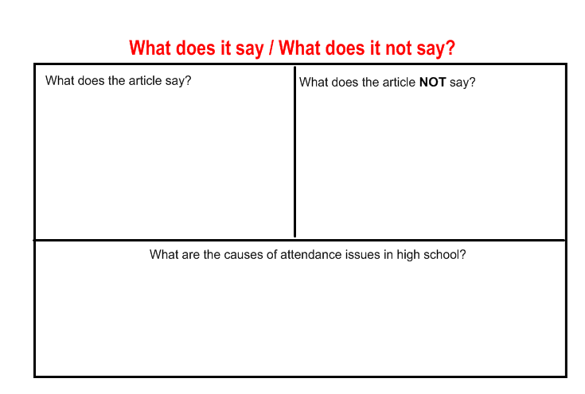
Reproduce this chart in your notes, making sure it takes up the entire page. Be sure to include quotes to support.

