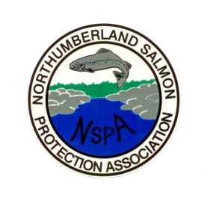

NORTHUMBERLAND SALMON PROTECTION ASSOCIATION

EILEEN MURPHY MEMORIAL SCHOLARSHIP 2012

APPLICATION FORM

Applications will not be considered complete until the following documentation has been received:

- Completed application form
- A copy of the applicant’s resume
- Two letters of reference
- Essay
- Letter of acceptance from University or College
- A current transcript of marks

Applications must be received no later than Friday April 27th, 2012 for consideration. Please forward all documentation to:

Shelley Ward-Cain
Secretary, N.S.P.A.
50 Flett Crescent
Strathadam, N.B.
E1V 4H8

PART A: PERSONAL INFORMATION

- Name of Applicant:

________________________________________________________________
First Middle Last

2. Date of Birth: _____________________ Telephone #: __________________
(d/m/y)

3. Home Address Mailing Address (if different)

__________________________ _________________________

__________________________ _________________________

__________________________ _________________________

__________________________ _________________________

- Parent(s)/Guardian(s) name(s): ___________________________________

___________________________________

PART B: EDUCATIONAL INFORMATION

- Name of High School: ___________________________

School District: ___________

6. University or College you plan to attend:

____________________________________

- Title of post-secondary program: ________________________________

- Average Annual Household Income*: _______________________________

9. Number of dependants in household: __________________

* All information provided by the applicant will remain confidential.

____________________________ ____________________
Applicant’s signature Date

