Public Class Form1
Dim Wrong As Single, Correct As Single
Private Sub Button1_Click(ByVal sender As System.Object, ByVal e As System.EventArgs) Handles btnFlip.Click
Dim r As Single
r = Int(Rnd() * 2) + 1
If r = 1 Then
picCoin.Load("Head.jpg") Find Pictures of a quarter showing heads. Place in the debug foldoer of your project
If txtGuess.Text = "Heads" Then
Correct = Correct + 1
lblGuess.Text = "Right"
lblRight.Text = Correct
Else
Wrong = Wrong + 1
lblGuess.Text = "Wrong"
lblWrong.Text = Wrong
End If
Else
picCoin.Load("Tail.jpg") Find Pictures of a quarter showing tails. Place in the debug foldoer of your project

If txtGuess.Text = "Tails" Then
Correct = Correct + 1
lblRight.Text = Right
lblGuess.Text = "Right"
Else
Wrong = Wrong + 1
lblWrong.Text = Wrong
lblGuess.Text = "Wrong"
End If

End If

End Sub

Private Sub btnExit_Click(ByVal sender As System.Object, ByVal e As System.EventArgs) Handles btnExit.Click
Me.Close()

End Sub

Private Sub Form1_Load(ByVal sender As Object, ByVal e As System.EventArgs) Handles Me.Load
ChDrive("C:\") This will be H:\ for your accounts
Randomize()
End Sub

Private Sub btnClear_Click(ByVal sender As System.Object, ByVal e As System.EventArgs) Handles btnClear.Click
picCoin.Load("")
lblGuess.Text = ""
lblRight.Text = ""
lblWrong.Text = ""
txtGuess.Text = ""
End Sub

Private Sub Label2_Click(ByVal sender As System.Object, ByVal e As System.EventArgs)

End Sub

Private Sub lblGuess_Click(ByVal sender As System.Object, ByVal e As System.EventArgs) Handles lblGuess.Click

End Sub

Private Sub txtGuess_TextChanged(ByVal sender As System.Object, ByVal e As System.EventArgs) Handles txtGuess.TextChanged

End Sub
End Class

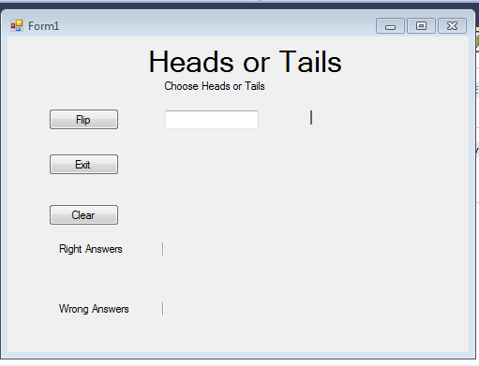
Pipi
Picture box where picture of the coin will show up

