E-mail Assignment BBT 9
- Open Microsoft Word and answer all of the following questions in bullet format:
    - Name
    - Grade
    - Homeroom Teacher
    - Interests (Inside and Outside School)
    - Do you work? If so where?
    - Discuss your computer experience? What applications/programs have you used?
    - What is your typing speed (snail/slow/medium/fast/lightning speed)?
    - Do you play any computer games? If so, name your favorite games or types of games.
    - Include one piece of interesting/unique information about you (for example, Mrs. Pleadwell has six sisters).
Save this document as “Email Assignment” in your “Others” folder.

- Open Microsoft Web Outlook - student.nbed.nb.ca or click on the icon on the first page when your browser opens. Type your domain nbss\login into the first box called username. Beside the password box, type your same password that you logged into the computer with.

- Click on the Calendar -Find your birthday on the calendar, click on the date and put Happy Birthday to Me!!! @ 8:00 am time slot. Save it and close.
  - Reopen it and then use the snipping tool to print off the daily calendar. Make sure I can see the month, day and the 8:00 am time slot.
  - Copy it with a right click and paste it into the word document.
  - Right click on the snip that you pasted, select “Text Wrapping” and make it “square” or “tight” so you can organize your three snips closer together.

- Contact- Add New Contact with just your teacher’s information :
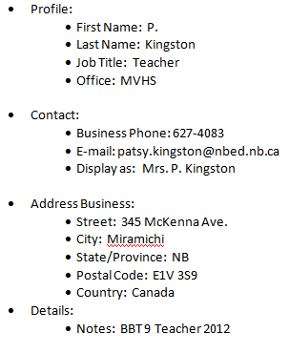
  - Profile:
    - First Name: A
    - Last Name: Pleadwell
    - Job Title: Teacher
    - Office: MVHS

  - Contact:
    - Business Phone: 627-4083
    - E-mail: andrea.pleadwell@nbed.nb.ca
    - Display as: Mrs. A. Pleadwell

  - Address Business:
    - Street: 345 McKenna Ave.
    - City: Miramichi
    - State/Province: NB
    - Postal Code: E1V 3S9
    - Country: Canada
  - Details:
    - Notes: BBT 9 Teacher 2012
  - Use the snipping tool to show this contact information. Copy to your word document and text wrap it as well.

- Tasks – Add a task
- Subject: English Report
- Start Date: September 17
- Due Date: September 28
- Reminder: September 24 at 8:30 am
- Don’t forget to save and close!!
- Copy this screen with this information and add to the word document.

- Final Step
  - Resave the word document that should have your bulleted answers plus three snips arranged attractively.
  - Email the word document (as an attachment) to me. Remember, you added me as a contact.

You will be marked out of 15 for this assignment.

