Sections for Writer’s Notebook:
1. Writing (Quickwrites, Freewrites) 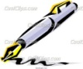
2. The Writer’s Eye (I): Lists of Things I Can Write About
3. Word, Phrase and Sentence Gems
4. The Art and Craft of Mechanics 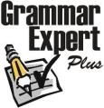

Sections for Writer’s Notebook:
1. Writing (Quickwrites, Freewrites)
2. The Writer’s Eye (I): Lists of Things I Can Write About
3. Word, Phrase and Sentence Gems
4. The Art and Craft of Mechanics

Sections for Writer’s Notebook:
1. Writing (Quickwrites, Freewrites)
2. The Writer’s Eye (I): Lists of Things I Can Write About
3. Word, Phrase and Sentence Gems
4. The Art and Craft of Mechanics

