Motif in The Outsiders
Motifs are repeating subjects, ideas, and features that help to develop and inform the novel's theme.

Example of a motif in The Outsiders: Eye shape and colour

Look at how Ponyboy describes his friends and family:

Darry: "...Darry's eyes are his own. He's got eyes that are like two pieces of pale blue-green ice. They've got a determined set to them." - p.6

Sodapop: "His eyes are dark brown --lively, dancing, recklessly laughing eyes that can be gentle and sympathetic one moment and blazing with anger the next."-p.8

Two Bit: "He had gray eyes and a wide grin..." - p.9

Dally: "His eyes were blue, blazing ice, cold with a hatred of the whole world." - p.10

Johnny: "He had big black eyes in a dark tanned face...He had a nervous, suspicious look in his eyes" - p.11

What is the importance of this motif to the story?____________________________________
__________________________________________________________________________________________________________________________________________________________________________
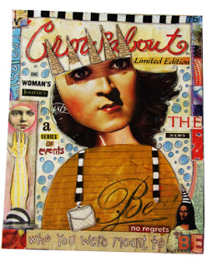
Motif Assignment:
Choose one character and create a visual image of the
character’s face. You must use magazine cutouts to
create the image – mix and match eyes, chins,
foreheads, etc. Use the character descriptions in
chapters one and two to assist you. Remember to
pay particular attention to the colour and shape of
the eyes.

