**Writing Craft and Mechanics Handbook**

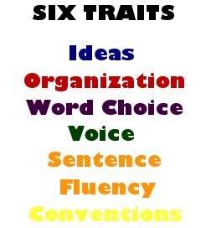

Your final assignment this semester is to create a Writing Craft and Mechanics Handbook. This is a great study strategy for your writing assessment. Your handbook will include tips regarding the grammar and craft lessons that we have covered this semester.

Your handbook must include information on each of the following topics:

* AAAWWUBBIS
* FANBOYS
* Conventional Artistry
* Apostrophes
* Quotation Marks
* Five Paragraph Essay
* Narrative Writing Tips
* Leads and Conclusions
* Transition Words
* Commonly Misspelled Words (you will be given these)
* Verb Tense Agreement (you will be given these)

Each topic should be given at least a half page of space in the handbook. You should include rules, tips – any information that you feel could help you during the writing process.

You are being marked on content and presentation. The information must be accurate, but it should also be presented in a way that is clear and pleasing to the eye. It should be something that could easily be used during an assessment. 