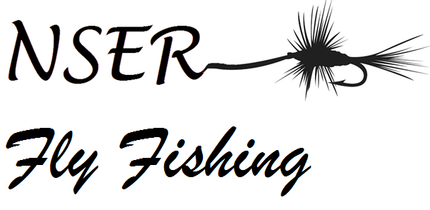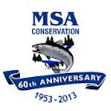
2013 NSER Fly Fishing Symposium
The NSER Fly Fishing Club and Outdoor Pursuits 110 Class, in partnership with the Miramichi Salmon Association, are hosting a unique competition focused on Fly Fishing for Atlantic Salmon. It will feature various casting events, a fly tying competition, and different seminars relating to all aspects of this great pastime.
It will be a cross curricular event that will expose all students attending to a broad range of educational experiences. Environmental Science, Biology, Hospitality and Tourism, Physical Education (Wellness through Phys Ed) are all courses that could be connected directly to this event. Students will not only be casting a fly rod and learning how to pursue this activity. They will be exposed to experts in the field of conservation and fisheries management. They will see various leisure and career opportunities associated with the outdoors. Students suffering from Nature Deficit Disorder will learn how to safely spend quality time outdoors participating in a great lifelong physical pastime.
Schedule for Friday May 31st at the Miramichi Salmon Association Hatchery in South Esk.

9:30am –Symposium will begin.
-Introduction and Schedule of Events.
-Location of events and washrooms. Use of safety glasses and water.
-Participates will receive scorecard and demonstration of each event. Judges will be stationed at each event to score casters.
9:45 am Session A (participants will select which of the following they wish to attend)
A1. Fly Casting Demo at Pond (basic casting)
A2. Knots (Clinch and the Turle)
A3. Fly Tying (Spinning Deer Hair)
A4. Fly Tying (Hair Wing)
A5. Knots (Blood Knot and Double Surgeon)
A6. Rod/Reel/Line Maintenance

10:15 am Break

10:45 am Session B (participants will select which of the following they wish to attend)
B1. Fly Casting Demo at Pond (Roll Cast)
B2. Casting Competition
B3. Knots (Clinch and the Turle)
B4. Knots (Blood Knot and Double Surgeon)

B5. Rod/Reel/Line Maintenance
B6. How to release a Salmon (ASF)
B7. Fly Tying Competition

11:15 am Session C (participants will select which of the following they wish to attend)
C1. Fly Casting Demo at Pond (Double Haul)
C2. Casting Competition
C3. Knots (Clinch and the Turle)
C4. Knots (Blood Knot and Double Surgeon)
C5. Rod/Reel/Line Maintenance
C6. Fly Tying Competition

11:45am – Lunch provided by Miramichi Salmon Association volunteers at no cost to participants. Hook and release fishing in trout pond may occur during this time
12:15pm – Guest Speaker (DFO/DNR) discussing conservation/regulations.
12:45pm – MSA Hatchery tour conducted by Biologist Alex Parker
1:45pm – Closing ceremonies. Award prizes to winners of both individual competitions and overall scores. Competition will be completed at this point.

On June 1st, the MVHS fly fishing club will be hosting interested participants for a day of fishing on the Main SouthWest Miramichi. Anyone interested in this venture are asked to contact Ashley Hallihan (Ashley.hallihan@nbed.nb.ca) to make arrangements. This is a great chance for students to put into action the skills they have developed.

On Saturday night, there will be a Salmon Dinner at NSER to benefit the school fly fishing club. Tickets cost $10 and are available from Debbie Norton (adventures@upperoxbow.com) Come out and celebrate this great sport we all enjoy and promote the future of fly fishing on the Miramichi.

