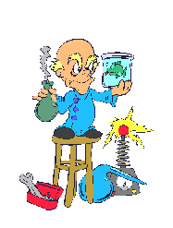
Natural Science
Science 9

Teachers: M. Burns, K. Cripps, S. Shannon, S. Verner
Textbook: Science 9 (Nelson)
Semester I: 2013 - 2014

Course Content:
Unit Two: Reproduction
- Cell growth and division
- Sexual/Asexual reproduction
- Development of an embryo
- Cloning, Mutation, Hormones
- DNA

Unit One: Space
- Exploring the Planets
- Formation of the solar system
- Exploring our Galaxies
- Materials and items in space

Unit Four: Electricity
- Electrostatics
- The Control of Electricity in Circuits
- Harnessing Electrical Energy
- The water cycle and its effect on weather

Unit Three: Atoms & Elements
- Matter and Change
- Elements and Compounds
- Models for Atoms
- The Periodic Table

Evaluation:
Tests & Quizzes 40%
Projects/Assignments/Notebooks 30%
Exam 30%

*****The pass mark for Science 9 is 60%*****

Attendance:

If you miss a day, it is YOUR responsibility to get caught up.
Use my website to access homework, handouts, etc that are related to the course. To get to the website, go to http://mvhs.nbed.nb.ca, then to “Teacher Pages”, and then click on my name.
Extra help is available upon the student’s request.

