Calculus 120
Integration Techniques
Evaluate each of the following integrals:
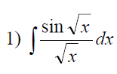 | 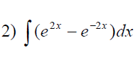 | 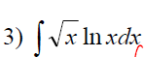
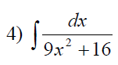 | 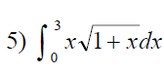 | 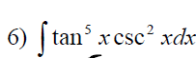
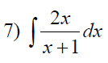 | 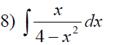 | 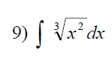
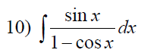 | 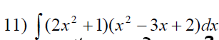 | 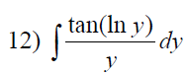
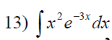 | 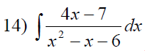 | 