“The Most Dangerous Game” by Richard Connell
Target Skill – Creating graphic organizers for focused note-taking
Create a detailed graphic organizer that depicts ONE of the following:
- How Rainsford’s character has changed from the beginning to the end of the story.
- How the setting is both a help and a hindrance for Rainsford.
You MUST include quotes from the story in your graphic organizer.
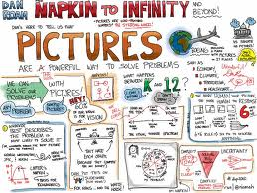
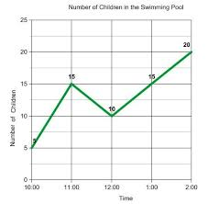
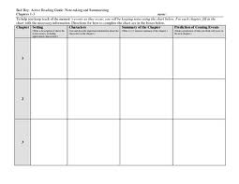
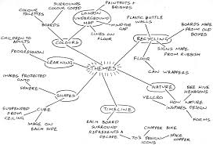
The following are examples of what graphic organizers might look like:

GRAPHIC ORGANIZER RUBRIC
Criteria | 4 | 3 | 2 | 1
Organization | Extremely well organized. Order & structure of information is compelling and flows smoothly. | Organized. Structure allows reader to move through content without confusion. Flows smoothly | Somewhat organized structure allows reader to move through some of the content without confusion. Flow is sometimes interrupted. | Poorly organized. A clear sense of direction is not evident. Flow is frequently interrupted.
Content | Thorough and insightful understanding of content. Quotes are used to support. | Complete understanding of content. One quote is used to support. | Shows some understanding of content. Quotes are not used to support. | Shows incomplete understanding of material.
Creativity | Clean design; high visual appeal; symbols/graphics used effectively. | Design is fairly clean, with a few exceptions; diagram has visual appeal; symbols/shapes are used. | Cluttered design; low in visual appeal; symbols/shapes are not used. | Shows minimal critical effort.
Ideas | Insightful and well considered ideas making multiple connections. | Ideas are considered; more than one thoughtful connection is made. | Ideas are somewhat on topic; makes some connections. | Ideas are unclear;  few connections are made.

