Connections Assignment
Make a text to self, text to text and text to world connection with your novel, and present the connections visually. You can present them in any way you choose, but remember to make it easy to read and understand.
Text-to-self:
What does this remind me of in my life?
What is this similar to in my life?
How is this different from my life?
Has something like this ever happened to me?
How does this relate to my life?
What were my feelings when I read this?
Text-to-text:
What does this remind me of in another book I’ve read?
How is this text similar to other things I’ve read?
How is this different from other books I’ve read?
Have I read about something like this before?
Text-to-world:
What does this remind me of in the real world?
How is this text similar to things that happen in the real world?
How is this different from things that happen in the real world?
How did that part relate to the world around me?

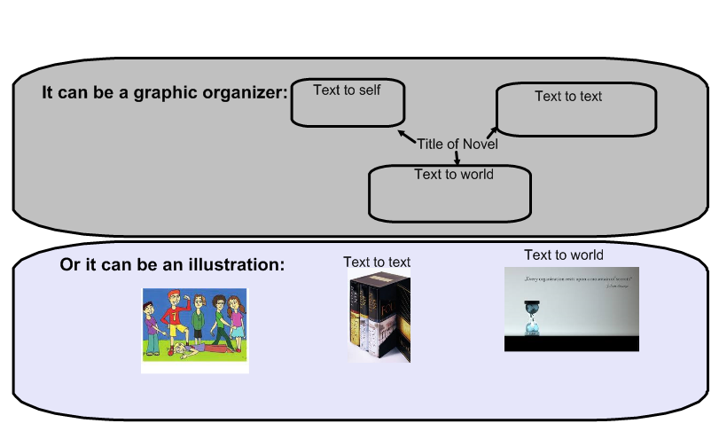
Make sure the connections are clear, have titles, and include an explanation (for the illustrations you can put the explanations on the back of the page if you prefer).
CONNECTIONS ASSIGNMENT RUBRIC
Criteria | 4 | 3 | 2 | 1
Organization | Extremely well organized. Order & structure of information is compelling and flows smoothly. | Organized. Structure allows reader to move through content without confusion. Flows smoothly | Somewhat organized structure allows reader to move through some of the content without confusion. Flow is sometimes interrupted. | Poorly organized. A clear sense of direction is not evident. Flow is frequently interrupted.
Creativity | Clean design; high visual appeal; easy to read | Design is fairly clean, with a few exceptions; diagram has visual appeal | Cluttered design; low in visual appeal | Shows minimal critical effort.
Ideas | Insightful and well considered connections. | Thoughtful connections are made. | Makes some clear connections. | Connections are unclear

