Reading Reflections

This semester, you are expected to read both during SSR and on your own time. For three of the novels you complete, you will have to show your understanding of what you read by completing a reading reflection assignment. These assignments show not only that you comprehend the novel, but also that you are able to connect the characters and issues in the novel to the real world.

You must complete three reading reflections, one for each due date. You can’t complete the same reading reflection assignment twice, but you can choose when you use each one. We will be using these reflection sheets for shared in-class reading, so you will understand how to use them all before the first due date.

Due Dates:
Reading Reflection #1: November 6
Reading Reflection #2: December 11
Reading Reflection #3: January 18

Reading Reflection Assignment options:
- The Most Valuable Idea
- Casting Call
- The Hunt for the Author’s Purpose
- Circles of Reflection

The Most Valuable Idea

In a complete sentence, write the most valuable idea found in the book:
______________________________________________________________________________________________________________________________________________________________________________________________________________________________________________________________________________________________________

Find an example in the real world that illustrates this idea and explain it here. You could also find an article, picture or website that shows this idea. | This idea is still valuable today because…..  (Explain the connection between the idea found in the book and the real-world example)
Casting Call

Characters in novels reflect people in the real world. For this reading reflection, imagine that your novel is being turned into a movie, and you have to choose an actor to play each character. Make your decisions carefully, and think about what connections an actor has to the character (don’t make your choices based on your favourite actors).

Character | Actor | Explain the actor’s connection to the character. Why would they do a good job in this role?

The Hunt for the Author’s Purpose

What was the author’s purpose in writing this book? Explain the purpose the author may have had in mind. Give specific passages or lines to support your answer.
____________________________________________________________________________________________________________________________________________________________________________________________________________________________________________________________________________________________________________________________________________________________________________________________________________________________________________________________________________________________________________________________________________________________________________________________________________
____________________________________________________________________________________________________________________________________________________________________________________________________________________________________________________________________________________________________________________________________________________________________________________________________________________________________________________________________________________________________________________________________________________________________________________________________________
____________________________________________________________________________________________________________________________________________________________________________________________________________________________________________________________________________________________________________________________________________________________________________________________________________________________________________________________________________________________________________________________________________________________________________________________________________
____________________________________________________________________________________________________________________________________________________________________________________________________

Circles of Reflection

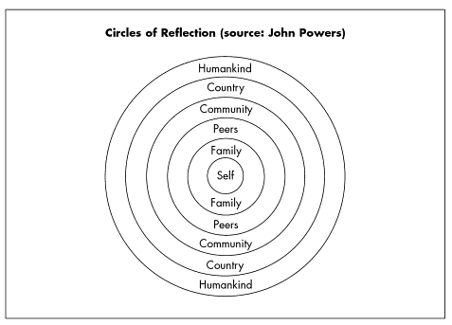
On the blank Circles of Reflection sheet, fill in the circles with a response for each category. You can also choose to show your answers with an illustration.

Self: What does this book mean to me? What connections do I have with it?
Family: What does the book mean in terms of my family? (Family can also mean close friends and loved ones)
Peers: Why should people my age be concerned with the issues presented in this book?
Community: How do the ideas in this book affect both my community and others?
Country: What does this book mean in terms of thinking about my country?
Humanity: What does this book mean about the human condition? What can I learn about humanity from reading this text? What are the universal truths it contains?

