Foundations of Math 120
Course OUTLINE – Fall 2015

Teacher: B. Mutch

Texts: Foundations of Mathematics 120 (Nelson)

Website: : http://math.mvhs.nbed.nb.ca
Like “Mrs. Mutch’s Math Page (MVHS)” on Facebook

Follow class on Twitter @MutchMathMVHS

Course Description:

This elective course follows Foundations of Mathematics 11. This pathway is designed to provide students with the mathematical understandings and critical-thinking skills identified for post-secondary studies in programs that do not require the study of theoretical calculus. This course will focus on

Materials Needed:

- Pencils and an eraser
- Notebook/Binder to maintain daily notes and homework exercises
- Scientific Calculator
- A box of Kleenex would be appreciated

Expectations:

The pace of this course will be rapid. Students will be expected to maintain excellent attendance. In the event of an absence, students are responsible for all missed work. (Please check the Math website noted above for missed notes and assignments.) If a student is absent for a test without a valid excuse, they will be given a mark of zero. It will be the responsibility of the student to present a satisfactory written excuse and arrange to write the test on his or her own time.

Topics:
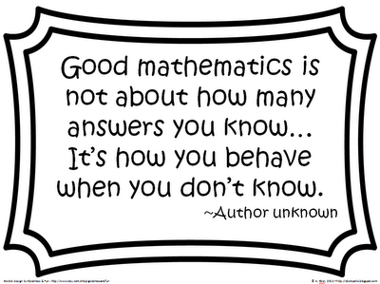
Statistics
Probability
Logical Reasoning
Relations and Functions

Evaluation:
Tests / Quizzes / Assignments 65 %
Midterm 10%
Exam 25 %

To Learn Math Is To Do Math !!!

