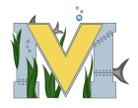
FINAL PROJECT BUSINESS MODEL
Names:
Project:
Part A: Problem
Part B: Solution
Part C: Key Metrics
Part D: Unique Value Propositions
Part E: Unfair Advantage
Part F: Channels
Part G: Customer Segments
Part H: Cost Structure/Revenue Streams ***Note – use a table for These Together!

