Test Notes for Visual Basic

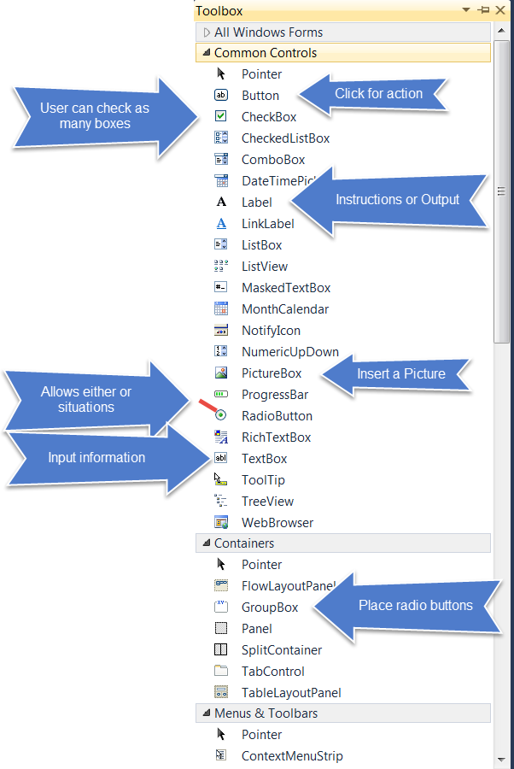

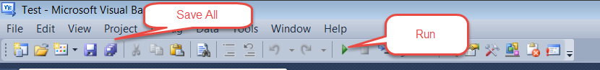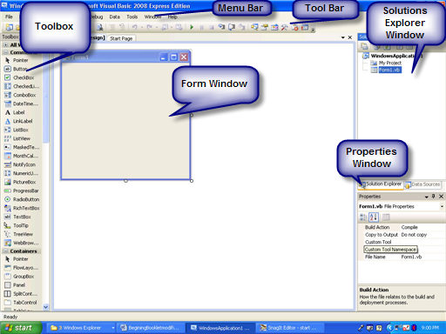
The Solutions Explorer Windows (The Project Window VB6)
Forms are saved as projects. If you need only one form in your program, then that project will contain only a single form. The project window lists the form names used in your project.

The Toolbox As you can see there are many different controls that can be used in a VB project. The most commonly used one are boxed in red.
The Properties Window Here is an example of two different objects with some of their properties. Some are the same while others are totally different.

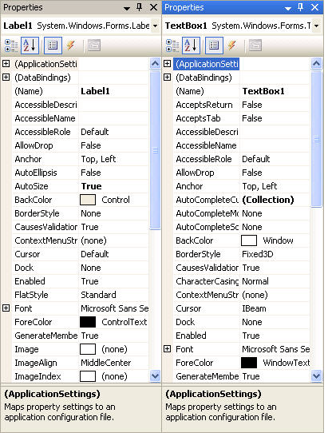

Naming Conventions

The way you name the controls placed on a form is important because the names are used to refer to the controls in the program code. Meaningful names make understanding the program code easier.

Textbox names start with the prefix “txt”. The prefix for labels is “lbl”, for Command (Formerly cmd) Buttons, “btn”, and for forms “frm”. The prefix is followed by one or more words describing the function of the control. No spaces are used. Each new word is capitalized. Here are some examples:
txtLastName
lblBirthPlace
txtUnpaidBalance
btnDisplayPicture
frmDisplay

Here is the list of prefixes:

Prefix Abbreviations for Control Names

Prefix | Control
cbo | Combo Box
chk | Check Box
btn | Button
dir | Directory list box
drv | Drive list box
fil | File list box
fra | Frame
frm | Form
grd | Grid
hsb | Horizontal scrollbar
img | Image
lbl | Label
lin | Line
lst | List box
mnu | Menu
ole | OLE client
Opt/rad | Option button /rad button
pic | Picture Box
shp | Shape
tmr | Timer
txt | Text box
vsb | Vertical scrollbar

Setting Properties for Forms,Textboxes, Labels, and Commands

Labels
Text—This is the text that the label will display
Name—The name of the label—eg. lblBirthplace—The Name is used to identify the label in code.

Textboxes
Name—The name of the Textbox—eg. txtLastName—used in code
Text—The text that you wish to see displayed, if any. Often this is just deleted as the user will fill in the textbox when the program is run.

Commands / Buttons
Text—Words you wish to see displayed on the command button.
Name—the name of the button—eg btnExit—used in code

Forms
Name—the name of the form—eg. frmTitle—used in code. This name will appear in the Project Window. It will also be used as the filename when you save the form.
Text—This text will appear in the Title Bar of the form.

Steps in Creating a Program

This is a three-step process.
- Select the object and arrange on the form.
- Set the properties of the form and the objects.
- Write the code.

To Write the Code—Attaching Actions to Objects

Double click on the object to get to the Code Window. Notice that Sub and End Sub are already there for you. Insert your code in between. For example, the code for the Exit button would be Me.Close. This command should be indented to make your code easier to read.

Double clicking on the form name in the Project Window will return you to the form. Then just double click on the next object you wish to attach code to.

