Drinking game death of teen leaves family wondering, 'Why?'

Brady Grattan of Fredericton, 18, died in Alberta after playing beer pong using hard liquor
By Shaun Waters, CBC News Posted: Feb 22, 2016 9:03 AM AT Last Updated: Feb 22, 2016 9:05 AM AT
Two and a half hours is all it took for Brady Grattan to go from a fun-loving 18-year-old to a young man on life support at a hospital in Grande Prairie, Alta.
Cory and Tracey Grattan of Fredericton want to make sure the story of their son's death on Feb. 4 after a drinking game — called beer pong — is known by as many people as possible, so it doesn't happen to any other family.
Brady graduated from Leo Hayes High School in 2015 and moved to Grande Prairie last July to pursue his dream of becoming a licensed welder. His grandmother lived in the Alberta town so he had a place to stay.
Then one morning in early February, the phone rang at his parents' home in Fredericton.
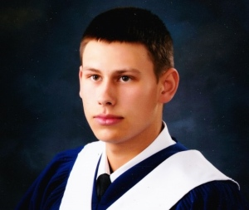
Brady Grattan graduated from Leo Hayes High School in Fredericton in 2015. (Submitted by Grattan family)
"It was about four o'clock in the morning and I knew," said Cory Grattan. "I knew something was wrong because we don't get a phone call at that time in the morning. Something happened in my spirit. I just knew something was wrong."
His mother-in-law was on the line from Grand Prairie. Brady was in the hospital in intensive care. "Everything's kind of a blur," Grattan remembers. "Time just sort of stopped for a minute. It was just like, this wasn't real. I'm dreaming and I'm going to wake up."
Ten minutes later he had the number for the doctor and he was calling the hospital in Grand Prairie asking about Brady and what had happened. "And the doctor got on the phone with me and told me exactly what was going on — that Brady had been found unconscious at a party, and um, they didn't really have the details," Grattan said.
"They wanted to, they were going to put him in hypothermia state, cool his body and then wake him up over 24 hours and I was hopeful." Grattan couldn't imagine what had taken place at the party and told his wife to pray for the best.
"I was saying, 'OK, he's going to learn from this bad experience, he's going to wake up, everything's going to be fine.'" Grattan says he was consumed by one thought. They had to get to their son's bedside as quickly as possible.
The timing of their son's accident couldn't have been worse. There had been a snow storm and airline officials told the Grattans that all flights going west were grounded. The only flight they could catch was 24 hours later.

'You have to get here'
Grattan called a friend in Alberta and asked him to go to the hospital and check on his son.
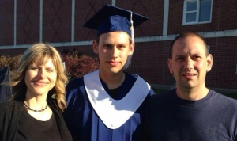
Brady Grattan with parents Tracey and Cory at his graduation from Leo Hayes High School. (Submitted by Grattan family)
"I was hoping that Jeff would go to the hospital and say, 'Oh ya, you know, Brady's fine you know, he's going to [be OK] "But that didn't happen." Jeff phoned back about an hour later with a chilling message. "He said, `You have to get here, you have to get to Alberta as fast as you can.'"​

Beer pong
As they talked to more people, more details about what happened came out.
Brady had been found unconscious in the basement of a home where a group of young people had been playing beer pong, a drinking game that involves teams of two and cups filled with beer.
The object of the game is to take turns throwing a ping pong ball into the other team's cups. If your ping pong ball lands in a cup, your opponent has to guzzle the beer.
The object of the game is to sink all your balls and get the other team drunk as fast as possible and win the game.
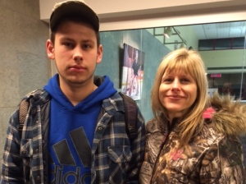
Tracey Grattan's last photograph with her son Brady, taken at Christmas. (Submitted by Grattan family)
But Grattan discovered the game their son participated in that night involved something more risky. "They were using hard alcohol. Brady was texting somebody at about 10 that night. He was in hospital in the ICU at about 12:45 a.m," Grattan said.
Grattan said between 10 p.m. and 12:45 a.m., he would have gotten into his vehicle, drove to the party and consumed an "incredible amount of alcohol really fast." "The ambulance was called. They came. They revived him, they took him to the hospital. He flat-lined on the way there, then they revived him again," Grattan said. "So all of this happened in like a two-hour span, consuming that much alcohol and ending up in ICU."
Grattan says even worse, he's learned that these drinking games are becoming pretty much part of the party scene for gatherings of young people these days.
"I beat myself against the wall, wondering you know, what are they doing in so little time to make all of this happen?" Grattan said.
"We're getting Facebook messages and text messages from people who know people and the stories are coming out that these kids are mixing Red Bull, they're mixing energy drinks, they're mixing hard liquor, anything to get a quick fix. And drugs. They're adding drugs to this too."
"So it's a whole new game now, and it's a dangerous game. It's a deadly game and I'd just like to bring awareness to people because you don't think it can happen to you?" Grattan said.
"I never imagined that it could happen to us."
Grattan says if one young person decides not to take part in a drinking game because of what happened to his son, then telling his story is worth it to the family.
The Grattans are even sharing the most intimate details of their experience to drive home their message.​ Tracey Grattan says senseless is the only way to describe what happened to her son Brady. She said she hopes his death helps other teenagers get the message about binge drinking and drinking games.
"Don't play them," she said. "Be smart. I mean don't make your parents go through this. Don't make anyone go through this."

