NSCC instructor frustrated with 'entitled' students

Province studies how to prepare high school graduates for jobs and further education
Angela MacIvor · Reporter · CBC News February 13, 2016
Nova Scotia Community College instructor says many students don't handle criticism well. (CBC)
High school students are being "coddled" on assignment deadlines, according to one instructor at Nova Scotia Community College.
Steffie Hawrylak-Young has taught communications at NSCC for almost 30 years. In the last decade, she says, there has been a shift in how her students adjust to college learning — and it's not good.
A provincial government survey indicates she is not alone in her frustration.
"A lot of our young students are very entitled," Hawrylak-Young told CBC News. "They have probably been used to getting a badge for every single little thing that they do, and they're very disappointed when they're being critiqued.
"In many of our businesses and industries, performance evaluation is very real, and they seem to have a hard time accepting that their performance is not there yet."

Flexible deadlines
Hawrylak-Young suggests high school teachers are allowing students to hand in assignments weeks or even months late. When students expect the same treatment in her class, she says, they are surprised.
"The late assignments just become bundled up and they never ever have a chance to get the feedback they need to improve for the next assignment. Further to that, it's a little disappointing when they don't care to improve," said Hawrylak-Young.
"Maybe they've been coddled. Maybe they've been allowed to make mistakes without consequences."
The Department of Education agrees there is need for improvement.
A transition task force was created following a Department of Education survey that received 4,000 comments from teachers and parents, many outlining the issues around deadlines and attendance.
Sandra McKenzie, deputy minister of education and early childhood development, is co-chairing the task force. It was created in response to complaints of students not being prepared for the workforce or post-secondary education.

Province-wide policy needed
"The objective of the transition task force is to look at key transition points and how can we make sure that they're transitioning successfully," said McKenzie.
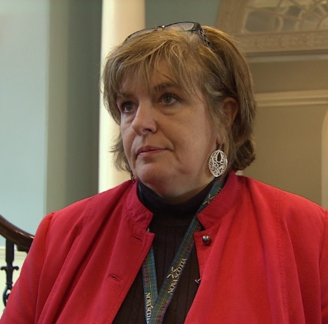
Sandra McKenzie, deputy minister of education and early childhood development, says there's a mix of guidelines across school boards. (CBC)
School superintendents, principals, business owners and post-secondary representatives are taking part in the discussions.
McKenzie recognizes there needs to be province-wide policy, rather than a "mishmash" of guidelines.
"In the past, the department created guidelines, and then each board would create its own policy and then each school would interpret the policy at the school level. What has resulted is that different practices across the province by schools."
The panel is expected to make recommendations to cabinet ministers by the end of March.

