**Part 1: Multiple Choice :**

GMF10

Mock Exam

1. Franco sells furniture for a living. He is paid 25% of the total amount he sells. This is called…

|  |  |  |  |
| --- | --- | --- | --- |
| a. | Salary | c. | Commission |
| b. | Wage | d. | Piecework |

2. Henry works as a waiter at the Portage. He earns $12.50/hour and keeps 70% of his tips. In one shift, he worked 8 hours and received $78 in tips for providing excellent customer service. Henry’s gross pay for the day is…

|  |  |  |  |
| --- | --- | --- | --- |
| a. | $154.60 | c. | $546 |
| b. | $54.60 | d. | $100 |

3. The listed price of a smartphone in Ireland is 350 euros. The same smartphone is listed here in Canada for $550.

Where is the phone cheaper? (1euro = 1.580814 CAD)

|  |  |  |  |
| --- | --- | --- | --- |
| a. | Canada | c. | Ireland |
| b. | Cost is the same | d. | Who needs a smartphone anyway? |

4. George is paid by commission. He works 35 hours a week and sells on average $250 000 worth of cars in a month.

If George is paid 14.2% commission, what is his average monthlycommision?

|  |  |  |  |  |  |  |  |
| --- | --- | --- | --- | --- | --- | --- | --- |
| a. | $35000 |  |  |  | c. $49700 |  |  |
| b. | $35555 |  |  |  | d. $35500 |  |  |

5. The regular price of ham at a the grocery deli is $1.54/150 g. If the ham is on sale for 30% off, what is the cost of

302 g?

|  |  |  |  |
| --- | --- | --- | --- |
| a. | $2.17 | c. | $3.10 |
| b. | $3.70 | d. | $139.52 |

6. Rosanne is paid $26.25 per hour for a thirty five hour week, with time and a half for overtime. If she worked 49 hours last week, how many overtime hours will she have?

|  |  |  |  |
| --- | --- | --- | --- |
| a. | $918.75 | c. | 14 |
| b. | $1470 | d. | 35 |

7. Rosanne is paid $26.25 per hour for a thirty five hour week, with time and a half for overtime. If she worked 49 hours last week, what is her gross pay?

|  |  |  |  |
| --- | --- | --- | --- |
| a. | $918.75 | c. | 14 |
| b. | $1470 | d. | 35 |

8. You invest $6000, at an interest rate of 4% compounded semi‐annually, for 5 years. How much

interest would you earn?

|  |  |  |  |
| --- | --- | --- | --- |
| a. | $1313.97 | c. | $6000 |
| b. | $7313.97 | d. | $6144 |

9. Allison saw an advertisement for a store sale offering all jewelry at 20% off. The necklace that Allison is

interested in retails for $108.56. How much will the necklace cost after 13% HST is applied to the price?

|  |  |  |  |
| --- | --- | --- | --- |
| a. | $84.03 | c. | $86.85 |
| b. | $98.14 | d. | $122.67 |

10. You invest $6650 in an account paying 4.34% per annum, compounded quarterly, for 6 years.

How much will you have at the end of 6 years?

|  |  |  |  |
| --- | --- | --- | --- |
| a. | $1731.66 | c. | $8615.94 |
| b. | $1965.94 | d. | $8381.66 |

11. Amanda is charged 19.65% per annum on her credit card balances. She uses her credit card with no

previous balance, for a cash advance of $680. What is the interest due if she takes 28 days to pay?

|  |  |  |  |
| --- | --- | --- | --- |
| a. | $3741.36 | c. | NONE |
| b. | $10.25 | d. | $133.62 |

12. What is Hank’s net pay if he has a gross income of $2500.00/month, lives in Miramichi, NB, qualifies for claim

code 3 and has deductions of $70.50 for CPP, $36.47 for EI, $30 for provincial tax, and $65.70 for federal tax?

|  |  |  |  |
| --- | --- | --- | --- |
| a. | $1500.00 | c. | $2363.03 |
| b. | $2297.33 | d. | $2393.03 |

13. Which of the following is the most appropriate Imperial units to use for measuring a person’s hand width?

|  |  |  |  |
| --- | --- | --- | --- |
| a. | Centimeters | c. | feet |
| b. | Millimeters | d. | inches |

14. Convert 605 yards into feet.

|  |  |  |  |
| --- | --- | --- | --- |
| a. | 605 feet | c. | 1815 feet |
| b. | 302.5 feet | d. | 201.7 feet |

15. Which measure is between 8 km and 12 km?

|  |  |  |  |
| --- | --- | --- | --- |
| a. | 10 miles | c. | 6 miles |
| b. | 13 miles | d. | 4 miles |

16. A contractor is ordering concrete for the foundation footing of a new garage. The foundation footing is 18cm

wide, 20 cm high and 16 m long. If concrete cost $55/m3, how much would it cost?

|  |  |  |  |
| --- | --- | --- | --- |
| a. | $31680000 | c. | $316800 |
| b. | $31.68 | d. | $31680 |

17. Tessie measures her bathroom tiles to be 15 inches wide by 9 inches long. What is the width in centimetres?

|  |  |  |  |
| --- | --- | --- | --- |
| a. | 35.4cm | c. | 24.5 cm |
| b. | 25.4 cm | d. | 38.1cm |

18. A walk-in freezer at a restaurant is kept at a temperature of 15°F. What is this temperature in degrees Celsius?

|  |  |  |  |
| --- | --- | --- | --- |
| a. | –9.4°C | c. | 9.4°C |
| b. | –23.7°C | d. | 23.7°C |

19. How many ounces is 68.7 grams?

|  |  |  |  |
| --- | --- | --- | --- |
| a. | 1951.08 oz | c. | 195.1 oz |
| b. | 2.4 oz | d. | 24.0 oz |

20. A seat on a ferris wheel can safely hold up to 1000 lb. If the average adult weighs 72 kg, how many passengers

can ride the ferris wheel at once?

|  |  |  |  |
| --- | --- | --- | --- |
| a. | 7 | c. | 6 |
| b. | 5 | d. | 8 |



21. Samantha is buying firewood for the winter and it is being sold for $250/ cord and she estimates she will need

400kg. If the conversion factor is 370 kg/cord, how much will she spend on firewood?

|  |  |  |  |
| --- | --- | --- | --- |
| a. | $270.27 | c. | $92500 |
| b. | $100000 | d. | $2702.70 |

22. Find the volume of this cone.

|  |  |  |  |
| --- | --- | --- | --- |
| a. | 3060 cm3 | c. | 3060 cm2 |
| b. | 2616.67 cm3 | d. | 2616.67 cm2 |

23. Sharon is painting the living room in her house. The room measures 20 feet long by 10 feet wide by 10 feet high.

She will only paint the walls and not the floor or ceiling. What is the total area Sandy will paint?

|  |  |  |  |
| --- | --- | --- | --- |
| a. | 2000 ft2 | c. | 1000 ft2 |
| b. | 800 ft2 | d. | 600 ft2 |

24. A cylindrical can has a radius of 8cm and is 12cm high. What is the surface area of a label if it is wrapped around

the entire can but not on the top or bottom lids?

|  |  |  |  |
| --- | --- | --- | --- |
| a. | 301.44 cm2 | c. | 602.88 cm2 |
| b. | 803.84 cm2 | d. | 502.4 cm2 |

25. What would the volume of the box that would be formed with this particular net?

(3cm squares are cut out of each corner.)

40cm

20cm

|  |  |  |  |
| --- | --- | --- | --- |
| a. | 2400 cm3 | c. | 1887 cm3 |
| b. | 1428 cm3 | d. | 800 cm3 |

26. One **horizontal ray is** drawn. From that ray, an angle of  is 68° is measured and a second ray is drawn.

Another horizontal ray is then drawn beginning at the vertex of the 68o angle, as shown below. The value of the

second angle created is:

1. Complementary to the 68o and measures 112o
2. Complementary to the 68o and measures 22o
3. Supplementary to the 68o and measures 112o
4. Supplementary to the 68o and measures 22o

68o

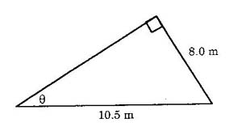27. To the nearest degree, what is the value of *θ* in the diagram?

a. 40º b. 45º c. 50º d. 53º

28. In the diagram shown, what is the length of ***RQ*** to the nearest tenth?

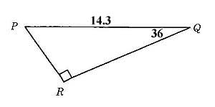

a. 8.4 b. 17.7 c. 10.4 d. 11.6

29. Find the length of the unknown side: (Round to the nearest whole number)

a. 25 b. 15 c. 16 d. 7

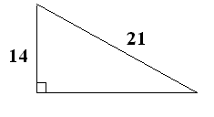

30. In the diagram below, opposing lines are parallel, angles B and C are:



|  |  |  |  |
| --- | --- | --- | --- |
| a. | Alternate exterior | c. | Corresponding |
| b. | Alternate interior | d. | Vertically opposite |

31. A rectangular box is 180 cm long and 32 cm wide. What is the length to the nearest cm of the longest fishing rod

that could be packed to lie flat in the box?

|  |  |  |  |
| --- | --- | --- | --- |
| a. | 182 cm | c. | 183 cm |
| b. | 177 cm | d. | 178cm |

32. A woman in a hot air balloon sees a bear in a field below, at an angle of depression of 56°. The horizontal

distance from the bear to the balloon is 40 m. How far above the ground is the hot air balloon?

|  |  |  |  |
| --- | --- | --- | --- |
| a. | 33.16 m | c. | 59.30 m |
| b. | 22.37 m | d. | 26.98 m |

33. A set of stairs has a vertical rise of 15 cm for every 26cm run. Determine the angle, to the nearest degree,

the stairs make with the floor.

|  |  |  |  |
| --- | --- | --- | --- |
| a. | 31 degrees | c. | 37 degrees |
| b. | 53 degrees | d. | 45 degrees |

34. If your CPP rate is 4.95% and your monthly salary is $4500, how much will be deducted from your pay?

($3500 exemption) [Don’t forget the three steps!!]

|  |  |  |  |
| --- | --- | --- | --- |
| a. | $291.67 | c. | $2083.12 |
| b. | $4208.33 | d. | $208.31 |

35. What is the complement of 68o?

|  |  |  |  |
| --- | --- | --- | --- |
| a. | 67 degrees | c. | 54 degrees |
| b. | 22 degrees | d. | 75 degrees |

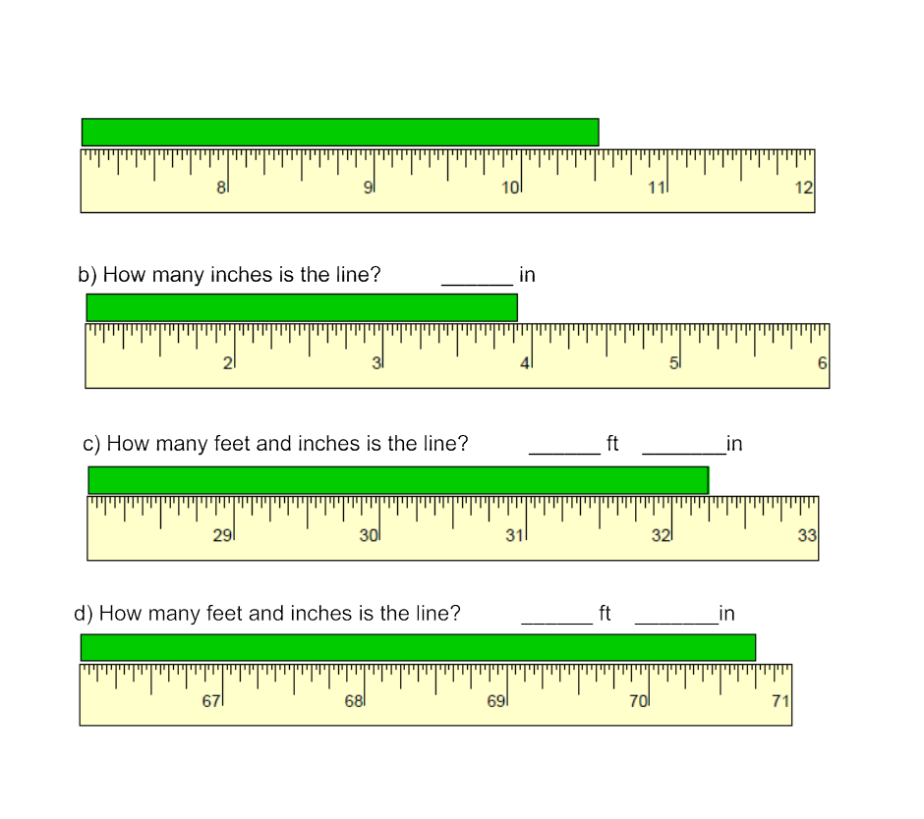

Open Resoponse:

1. For each of the following determine the lengths: a) Inches _______
2. Make the following conversions:
3. 7265 ft = _____mi b) 66 ft2 = _____________in2  c)203 yd3 = ___________ft3

d) 13 km= _________ft e) 13 ml = ___________ in3 f) 17 British gallons = ______ British pints

g) 180 cm3 = _______ tbsp h) 20 L = _____ Us gal i) 14oC =______oF j) 525oF = ______oC

k) 149 oz = ___ lbs ___ oz l) 5 kg = _______ oz m) 52 kg = ______ lbs n) 4.5 t = ______lbs

1. 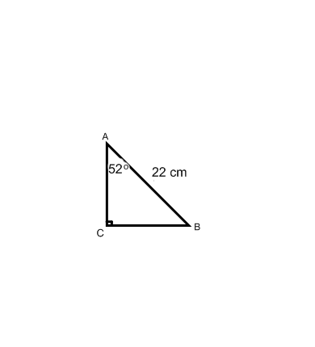Solve the following right triangle…

4) Calculate the volume of the following figure.

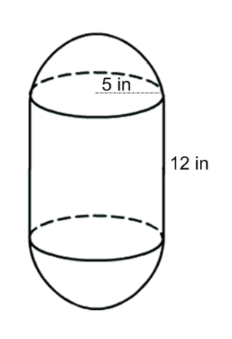

b

a

***a* = _____ *b* = _____** = _____

6) Calculate the volume, in ft3.

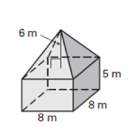

5. Calculate the **surface area** of the following

using **yards.** (Include all sides.)

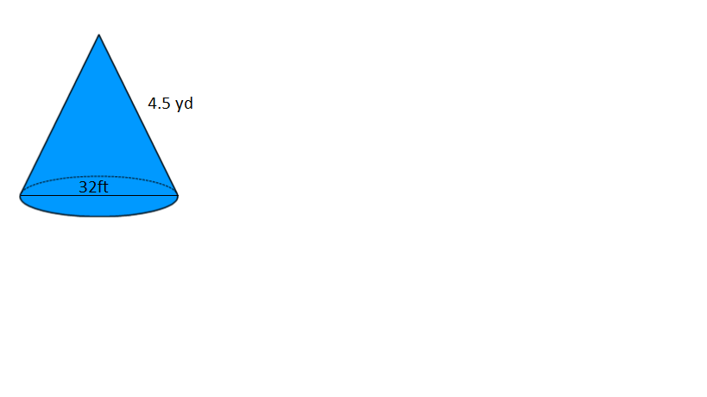

7) Bob is following a recipe for pancakes that calls for 6 cups of water,  cups of molasses, and 3.5 tsp

of vanilla . **What will the total volume of the ingredients be in mL if he makes a double batch?**

8) a) Jill has to exchange $3200 or his trip to Egypt . How much is that worth in that pound?

|  |  |  |  |
| --- | --- | --- | --- |
| **Canadian Bank Foreign Exchange Rates for Buying and Selling** | | | |
| **Country** | **Currency** | **Buying Rate** | **Selling Rate** |
| France | Euro | 1.580814 | 1.644814 |
| Egypt | Pound | 0.159300 | 0.217300 |

1. Jill’s trip got cancelled and must change his money back into Canadian dollars. What does she receive back?

9) Sarah works as a LPN where she is paid $22.30 per hour, and gets paid bi-weekly. She pays bi-weekly deductions of $18.47 for union dues and $32.50 for her medical plan. Knowing that she 35 hours a week, calculate her net pay using **claim code 2**. **CPP = $__________**

**EI = $__________**

**Fed. Tax = $__________ Prov. Tax = $________**

**Other = $ ________**

**Gross Pay = $________ Taxable Income = $________ Net Pay = $________**

10) Miss Burns has just won $25 354.00 on Gold Rush, financial advisor gives her two investment options that she can choose from …

**OPTION A**: *5%/a compounded quarterly* **OPTION B**: *6%/a Simple Interest*

Miss Burns intends to invest the winnings for **10 years** . Determine how much money each of these investment options would be worth in 10 years, and indicate which option she should choose

**11)** Sam is planning on building a rectangular boat dock, measures 8 metres by 5 metres The lumber costs $6.49/ft2, what will be the cost to purchase the hardwood flooring? (no Tax)

ANSWERS:

Multiple Choice Answers:

1) c 2) a 3) a 4) d 5) a 6) c 7)b 8)a 9) b 10)c 11) b 12)b 13) d 14) c 15)c 16)b 17)d 18)a 19)b 20)c 21)a 22)b 23)d 24)c 25)b 26) c 27) c 28)d 29)c 30)b 31)a 32)c 33)a 34)d 35)b

Open Response answers:

1a) 10 ½ b) 3 $\frac{29}{ 32}$ c) 2ft 8 ¼ in d) 5ft 10 3/4 in

2a) 1.38 mi b) 9504 in2 c) 5481 yd3 d) 42 650.4 ft e) 0.79 in f) 136pint g) 12 tbsp

h) 5.3 gal i) 57.2 oF j) 273.9 oC k) 9lbs 5 oz l) 176 oz m) 114.4 lb n) 9900 lbs

3) <B= 38o, a= 17.3cm , b= 13.5cm 4) 1466.10 in3 5) 164.8 yd2 6) 15 820.4 ft3 7) 3660 ml

8a) 14726.19pounds b) $2345.88

9) Gross pay= $1561 Taxable income= $1542.53 CPP= $70.61 EI= $29.35 Other=$32.50

Federal Income tax = $232.25 Provincial Income Tax= $140.20 Net Pay=$ 1037.62

10) Option A: Interest= $16 318.33 Option B: Interest = $15 212.40 so Option A is the best option

11) $2794.27

**Geometry, Measurement and Finance 10 – Conversions**

**SI length Imperial length**

|  |
| --- |
| 1 cm = 10 mm  1 m = 100 cm  1 km = 1000 m |

|  |
| --- |
| 1 m = 1.0936 yd  1 mi. = 1.6093 km  1 in. = 2.54 cm  1 m = 3.2808 ft. |

|  |
| --- |
| 1 ft. = 12 in.  1 yd = 3 ft.  1 mi. = 1760 yd |

|  |
| --- |
| **SI Capacity**: 1L = 1000 mL  1 kL = 1000 L  **SI Volume**: 1 ${cm}^{3}$ = 1 mL |

**TEMPERATURE CONVERSIONS…**

**C = $\frac{5}{9}\left(F-32\right)$ F = $\frac{9}{5}C+32$**

**SI mass Imperial mass**

|  |  |  |
| --- | --- | --- |
| 1 g = 1000 mg  1 kg = 1000 g  1 t = 1000 kg | 1 kg = 2.2 lbs  28.4 g = 1 oz | 1 lb = 16 oz  1 tn = 2000 lb |

|  |  |
| --- | --- |
| ***US Imperial*** | ***SI*** |
| 1 fl oz | 29.5735 mL |
| 1 pt = 16 fl oz | 473.176 mL or 0.473 L |
| 1 qt = 2 pt | 946.352 mL or 0.946 L |
| 1 gal = 4 qt | 3785.4 mL or 3.785 L |

**Converting Common Cooking Units**

|  |  |
| --- | --- |
| ***Imperial*** | ***SI*** |
| $1/{4 }$ teaspoon | 1.25 mL |
| $1/{2 }$ teaspoon | 2.5 mL |
| 1 teaspoon | 5 mL |
| 1 tablespoon (3 teaspoons) | 15 mL |
| 1 cup | 250 mL |
| 1 pint | 568.2614 mL |
| 1 quart (2 pt) | 1.1365 L |
| 1 gallon (4 qt) | 4.5461 L |

**Geometry, Measurement and Finance 10 – Formulas**

**Area of 2-D shapes**

$A_{rectangle}=lw$

$A_{triangle}=\frac{bh}{2}$

$A_{circle}=πr^{2}$ Circumference = $2πr$**or $πd$**

$A_{trapezoid}=\frac{h\left(a+b\right)}{2}$

**Surface Area and Volume of 3-D objects**

${SA}_{prism}=Add area of all the faces$ ${ V}_{prism or cylinder}=A_{base }x h$

${SA}_{cylinder}=2πr^{2}+2πrh$ ${ V}_{cone or pyramid}=\frac{A_{base }x h}{3}$

${SA}_{cone}=πr^{2}+πrs$ $V_{sphere}=\frac{4}{3}πr^{3}$

${SA}_{pyramid}=A_{base}+(area of the triangular faces)$

${SA}_{sphere}=4πr^{2}$

**Trigonometry Finance**

$c^{2}=a^{2}+b^{2}$ CPP: [Gross - (3500 /#pay) ] x 0.0495

$sinθ=\frac{opp}{hyp}$ EI: 1.88% of gross

$cosθ=\frac{adj}{hyp}$ Simple Interest: I = Prt & A = P + I

$tanθ=\frac{opp}{adj}$ Compound Interest: A = P ${\left(1+\frac{r}{n}\right)}^{nt}$& I = A - P