Puppeteers test visual creativity with ‘Hamlet’
By Xu Wei | November 18, 2016, Friday |

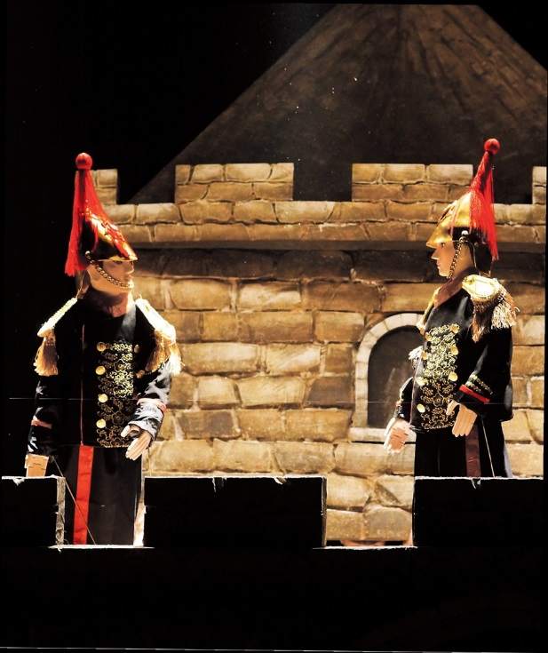

FOR centuries, Shakespeare’s works have found voices in several art forms including theater, cinema, musical and even dance-drama.
In China, they have been tried and tested in traditional performance arts like the Peking Opera. And now, as the world commemorates the 400th anniversary of the death of Bard, one of his famous tragedies, “Hamlet,” will be narrated through puppets.
Qin Feng, a teacher of puppetry at the Shanghai Theater Academy, has created this Shakespeare’s classic that won him the Best New Artist award at the 18th Shanghai International Arts Festival.
On Sunday, it will be staged at Shanghai 21st Century Minsheng Art Museum, as part of a series of programs organized by Shanghai Library, entitled “I Love Reading,” that aims to promote diverse styles of reading of classical works in the digital era.
Qin, who is the director and scriptwriter, worked on the production along with his students. He will share his experience with the audiences, while also talking about the long history and distinctive artistry of puppetry.
The 45-minute puppet show of “Hamlet” — a first in the world — is told in four acts.
In the third act, the art of shadow puppetry is especially used to recreate the scenes narrated by the ghost of how Hamlet’s father, the king of Denmark, is murdered by Hamlet’s uncle.
The 30-year-old Qin, and his 20-odd students, has been involved in the production of the classic and recreating it for the stage. They have worked on the characters and designed and crafted the sets.
As puppets don’t have facial expressions, it is absolutely a bold attempt to work on this play.
“To make the puppet characters look more vivid and impelling on stage, three students manipulated the head, hands and legs of each character,” Qin says. “It requires a lot of practice for coordination. Even though it is a simple movement of turning around, it takes much work.”
Adaptation of a household classic was another challenge.
“We need to look up to classics and show our respect,” he explains. “We can’t casually make changes to the story lines, characters and relationships. However, we also need some little innovation and creativity, which may better conform to the presentation styles of puppetry.”
Shadow play, or leather silhouette show, is an ancient Chinese art form of storytelling and entertainment. Both puppetry and shadow play have a history of more than 2,000 years. The shadows of ingenious leather puppet images are projected onto a backlit curtain by background lighting. The artisans manipulate the articulated images behind the screen following opera music, singing and dialogues.
Both puppetry and shadow originated in the Western Han Dynasty (206 BC-AD 24) and flourished in the Tang (AD 618-907) and Song (960-1279) dynasties.
Qin feels it his responsibility to preserve and promote the ages-old puppetry.
“Puppetry is an art form of strong vitality and it is easy to understand,” he says. “It has a magic of transcending the boundaries of time and space while it also has the potentials of merging with other theater arts to breathe fresh life.”
In his eyes, puppetry is definitely not just for children, but also for adults. He mentions the success of the puppet show “The Orphan of Zhao,” and the multimedia shadow play “Mulan” helmed by famous film director Sherwood Hu.
Incidentally, the Shanghai Theater Academy’s puppetry major is the only one of its kind in China. Since coming into existence in 2004, more than 200 students have graduated with expertise in puppet production and performance. Many of them are still active in puppetry, theater arts and other relevant industries.
Qin considers puppetry a rewarding experience to nurture young students and inspire them and revive the intangible cultural heritage with creativity.
“Hamlet”
Date: November 20, 2-4pm
Venue: Shanghai 21st Century Minsheng Art Museum, 1929 Expo Ave, Pudong

