Ernest Hemingway exhibit opens Oct. 22 at Misericordia University
For Dallas Post

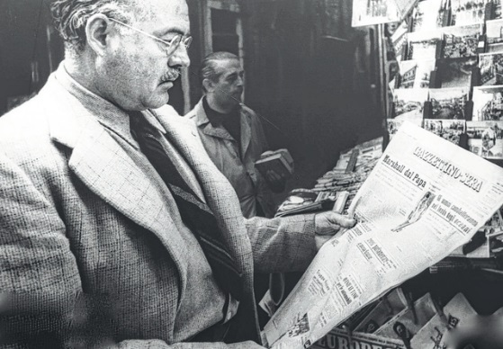
Nobel Prize-winning novelist, short-story writer and journalist Ernest Hemingway reads the front page of the Gazzettino Sera at the St. Mark’s newsstand in Venice, 1948.
DALLAS TWP. — The Misericordia University College of Arts and Sciences, Pauly Friedman Art Gallery and the Soyka Fund for the Humanities are bringing together a collection of pictures, experts and students for a series of events during the fall semester to recount the life and work of American writer Ernest Hemingway.
His writing style is considered among the most influential prose of the 20th century. Hemingway penned such classics as “The Sun Also Rises,’’ “A Farewell to Arms,” “The Old Man and the Sea,’’ “From Whom the Bell Tolls,’’ and many more.
Fans of the late Nobel Prize-winning novelist, short-story writer and journalist will be able to hear a first-hand account of his life from his former secretary, Valerie Hemingway, during the opening of the exhibit, “Hemingway and the Veneto,’’ in the Pauly Friedman Art Gallery on Saturday, Oct. 22. The exhibit in the gallery runs through Dec. 10.
The exhibition, on loan from Venice International University, showcases photographs of Hemingway and the people, places and things that were dearest to him during two important eras of his life: World War I and his time in Venice and Veneto, the northeastern region of Italy that surrounds Venice. Photographs include the Italian town of Fossalta di Piave, where Hemingway was wounded as an 18-year-old ambulance driver for the American Red Cross, and scenic areas in Italy he visited while writing “Across the River and into the Trees’’ in the late 1940s and early 1950s.
Valerie Hemingway will offer the keynote for the opening reception’s program, “Perspectives on Hemingway and the Image: A Symposium on the Life and Writing of Ernest Hemingway,’’ on Saturday, Oct. 22 at 5 p.m. in Lemmond Theater in Walsh Hall. The program also features student paper presentations from noon to 3 p.m. in Dudrick and Muth Rooms 216-217 of Sandy and Marlene Insalaco Hall.
Nationally known Hemingway scholars will participate in a roundtable discussion from 3 to 4:30 p.m. in the Friedman Art Gallery. Panelists include the editor of the Hemingway Review Suzanne del Gizzo, Ph.D., Chestnut Hill College, Philadelphia; the lead editor on the Cambridge University Hemingway Letters Project Sandra Spanier, Ph.D., Penn State University; leading Hemingway scholar and Hemingway Board member Linda Miller, Ph.D., Penn State Abington; and president of the Hemingway Foundation and Society H.R. Stoneback, Ph.D., State University of New York, New Paltz.
The program and exhibit are open, free to the public.
The gallery is closed on Mondays and for all university holidays and snow days. Gallery hours are Tuesday through Thursday, 10 a.m. to 8 p.m., Friday 10 a.m. to 5 p.m., and Saturday and Sunday 1 to 5 p.m. For more information, please log on to www.misericordia.edu/art or contact Dona Posatko, gallery director, at 570- 674-6250.

Information provided by Misericordia University.

Mixing it up in Cuba, Hemingway style
By Shari Darling, The Peterborough Examiner (Friday, October 21, 2016 1:34:10 EDT PM)
Winter is close. It is that time of year when we start planning our trip to Cuba.
This past year Jack and I travelled to Varadero, Cuba. We choose this location for a reason. Our mission was to visit Havana, specifically to tour Ernest Hemingway's home and his favourite hangout in Havana called the Floridita to enjoy a Hemingway Dairquiri.
Jack has Alzheimer's and so visiting Cuba and these locations had been on his bucket list for decades. We decided to take the trip while still possible.
As the story is told, one morning while walking along Bishop Street (Calle Obispo) in Havana, Hemingway came upon the Floridita fish restaurant and cocktail bar. He entered to use the bathroom. While leaving he noticed patrons sipping a fancy drink. The daiquiri. Hemingway had the bartender prepare his own version of this drink, and the Hemingway Daiquiri was born. Hemingway continued to frequent the Floridita from 1932 to 1939 while living down the street from the Floridita at the Hotel Ambos Mundos.
From that day forward Hemingway visited the Floridita each day to sip his daiquiri and read the daily newspaper. He also brought his friends to this magical place, including Gary Cooper, Tennessee Williams, Spencer-Tracy and Ava Gardner.
According to Hemingway's children, after moving into their farmhome just outside of Havana, their father and his wife Martha Gelhorn ("Mary") would drive to the Floridita for drinks.
Upon arriving in Cuba I hunted for a Hemingway tour. I was surprised to learn that it did not exist. Other tours included Hemingway's house or the Floridita. But there was no specific tour dedicated to Hemingway's life in Cuba. We were deeply disappointed. Then, by change and blessing we met at our resort pool a Canadian from St. Thomas, Ontario, named Shaun Russell, who manages a Tim Horton's. Shaun introduced us to his close Cuban friend and an incredible tour guide named Hesbiel. A former teacher, Hesbiel speaks fluid English!
Hesbiel arranged to pick us up at the resort in an old 1950's Ford. He makes all the arrangements for the day. Hesbiel guided us on our Hemingway tour to Havana, a nine-hour excursion. This was a dreadfully hot day, and Hesbiel took control of Jack's well-being, helping him up and down steps and into doors, throughout the excursion. I was moved by Hesbiel's compassion toward Jack. They became instant friends. I will cherish our day with Hesbiel and our Hemingway tour for the rest of my life.
We visited Hemingway's farmhouse, dined for lunch in the country, and visited the Floridita.

