What / So What or Quotation Illustration Assignment

Due: Friday, April 8
15 marks

Choose one assignment to complete.

What / So What

Choose 5-6 plot events from The Outsiders to complete the following chart. List the event under the “What” category, and in the “So What” category explain its larger significance to the novel. Be sure to explain yourself clearly in the “So What” category- don’t just write one or two words.
What | So What
Example:  Ponyboy cuts his hair | Ponyboy cuts and bleaches his hair in order to disguise himself, but is upset at this because cutting his hair means losing his identity as a greaser. Ponyboy considers his hair his pride: “Our hair labeled us greasers, too – it was our trademark. The one thing we were proud of. Maybe we couldn’t have Corvairs or madras shirts, but we could have hair” (page 71).
__________________________________________________________________________________________
Quotation Illustration

Choose a significant quotation from The Outsiders and create an illustration for it. The page must also include the quotation and the page number. The illustration should be well done (no stick figures, please), and emphasize the significance of the quotation. Don’t just draw what is going on in a scene.

Example from Indian Horse by Richard Wagamese:
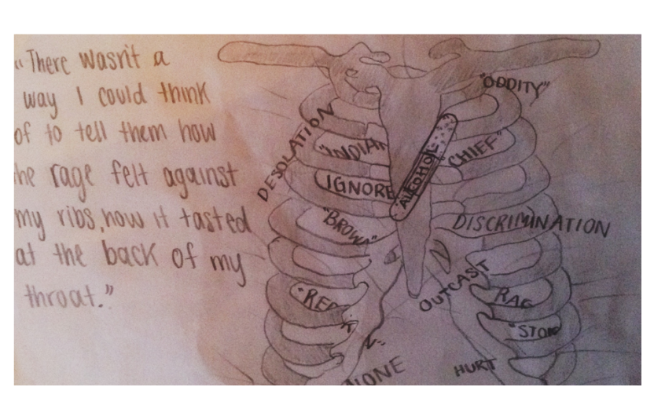
This quotation and illustration represents the protagonist’s experiences in Residential School.

