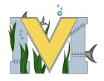
PROJECT #1 PROPOSAL
Name(s):
Technology:
Part A: Project Ideas & Objectives
Part B: Electronic Resources
Part C: Materials, Design

