**Nutrition for Healthy Living 120 – Exam Review**

**Exam Outline**

Multiple Choice – 50  
True/False – 20  
Short Answer –  
Charts/Labeling –

**Definitions**

nutrition heredity dehydration lipids  
nutrient diuretic   
metabolism wellness water intoxication chronic disease   
hydrogenation digestion energy excess balance  
blood lipid profile risk factor saccharide satiety

**To Know**

* 6 basic nutrient groups
* The wellness wheel
* Controllable / uncontrollable risk factors
* How to determine energy values
* Canada’s Food Guide (teen requirements, best source of foods high in starch)
* Serving sizes
* Simple vs. complex sugars
* Energy deficiencies causes
* Recommended sugar intake
* Sugar units (mono, di, poly)
* Importance of breakfast / timing
* Ingredients order (by weight)
* Function of electrolytes
* LDL / HDL

**Questions**

1. What is the body’s preferred source of energy?
2. Which carb has the most bulk?
3. What benefits can physical activity provide?
4. Where does an athlete’s calories come from?
5. For most adults, what percentage of their body is water?
6. Do complete proteins come from plant or animal sources?
7. What is the difference between a whole grains vs. a refined grain?
8. Who has the best knowledge of nutrition?
9. What happens to your blood glucose after eating?
10. What percent of your daily calories should come from saturated fat?
11. Which type of fat is only in animal products?
12. Water is the main component in ______________.
13. What foods are good sources of vitamin A?
14. Do we need to eat cholesterol? Why?
15. Do active people require more servings than inactive people? Why?
16. Can foods rich in fibre help you lose weight?
17. Food is not a source of water. True or false?
18. A vegetarian diet is not fat free. True or false?
19. Where is intracellular water found?
20. Which vitamin is known as the sunshine vitamin?
21. What is CHD?
22. In New Brunswick, what is milk fortified with?
23. What can a deficiency in folic acid cause?
24. Proteins that defend the body against infection and disease are ______________.
25. What influences our food choices?
26. Which vitamins are fat-soluble? Water soluble?
27. What will happen to you if you continue to not get a vitamin?

**Extra Practice**

*Carbohydrates*

|  |  |  |
| --- | --- | --- |
| **SIMPLE CARBOHYDRATES** | | **COMPLEX CARBOHYDRATES** |
| **( )saccharide** | **( )saccharide** | **( )saccharide** |
|  |  |  |
|  |  |  |
|  |  |  |

*Determine the Energy Values*

1. Chicken – 4 g of fat, 20 g protein, 3 g carbohydrates

Protein: ______ x ______ = ______ cal   
Fat: ______ x ______ = ______ cal 3. Potatoes – 4 g protein, 0 g fat, 41 g carbohydrates  
Carbohydrates ______ x ______ = ______ cal Protein: ______ x ______ = ______ cal

Fat: ______ x ______ = ______ cal

1. Brown Rice – 23 g carbohydrates, 1 g fat, 3 g protein Carbohydrates ______ x ______ = ______ cal  
   Protein: ______ x ______ = ______ cal

Fat: ______ x ______ = ______ cal  
Carbohydrates: ______ x ______ = ______ cal

*Label Comparison*

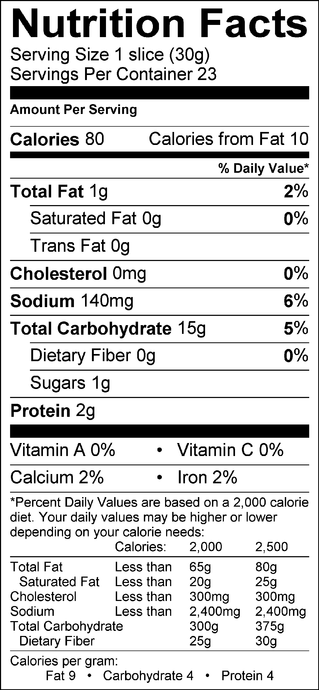Examine the two nutrition labels and answer the following questions.  
   
 **WHOLE WHEAT BREAD WHITE BREAD**

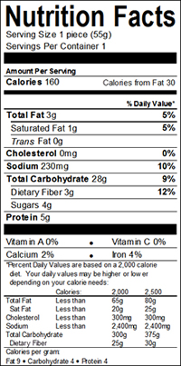

1. Which would you choose if you were trying to limit your fat intake?
2. Which would you choose if you were trying to limit your calorie intake?
3. Which product is higher in protein?
4. Which product would you choose if you were trying to increase your fiber intake?
5. Which product is a better source iron?
6. Nutrition labels are based on a daily diet consisting of how many calories?

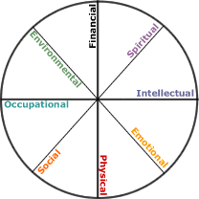

*Wellness*

*-What makes a life   
 “well”?*