The coil has multiple strands-like a rope to apply it to multiple batteries (or to charge more volts)
All that’s needed is to have an anti-magnet or demagnetizer (nail for example) in the middle. Next I assemble the magnets on a wheel...
The only hard part was stranding it like rope because you need a lot of room and some days it was windy outside so I postponed it a couple times.
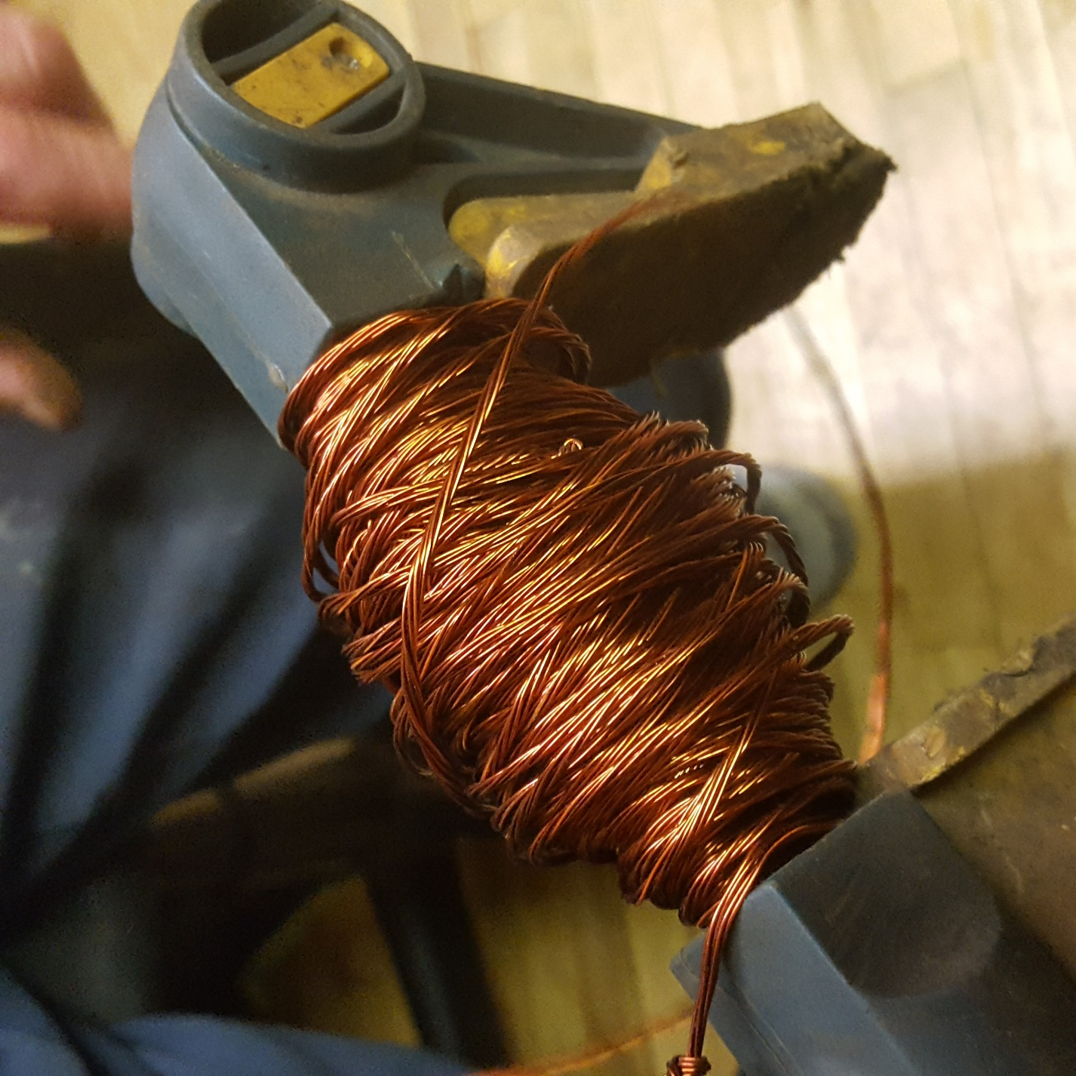
It probably shouldn’t have taken that long to assemble a coil, but it took 4 hours to do it in one day. And I didn’t exactly want to mess it up. Because I did a couple times at school.

