DRAWING CIRCUITS ASSIGNMENT NAME:

Look at the circuits below:

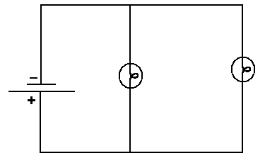
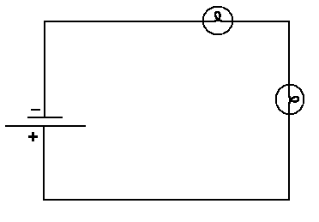

1. Which circuit do you think is a parallel circuit and which circuit is a series circuit?

2. How are the two circuits different? Explain.

Now, draw each of the circuits described, using proper circuit symbols.

A battery running three lights and a motor in series.

Three batteries running two motors in parallel.

Two batteries running a light and a motor in parallel. Include a switch that controls only the motor.

A
A battery running two light bulbs in series. Include an ammeter (symbol: ) that is used to measures current between the two bulbs.

A battery running four light bulbs in parallel. Include switches that control each light bulb and a switch that controls all the lights at once.

