Animals + Adaptation

Canadian goose
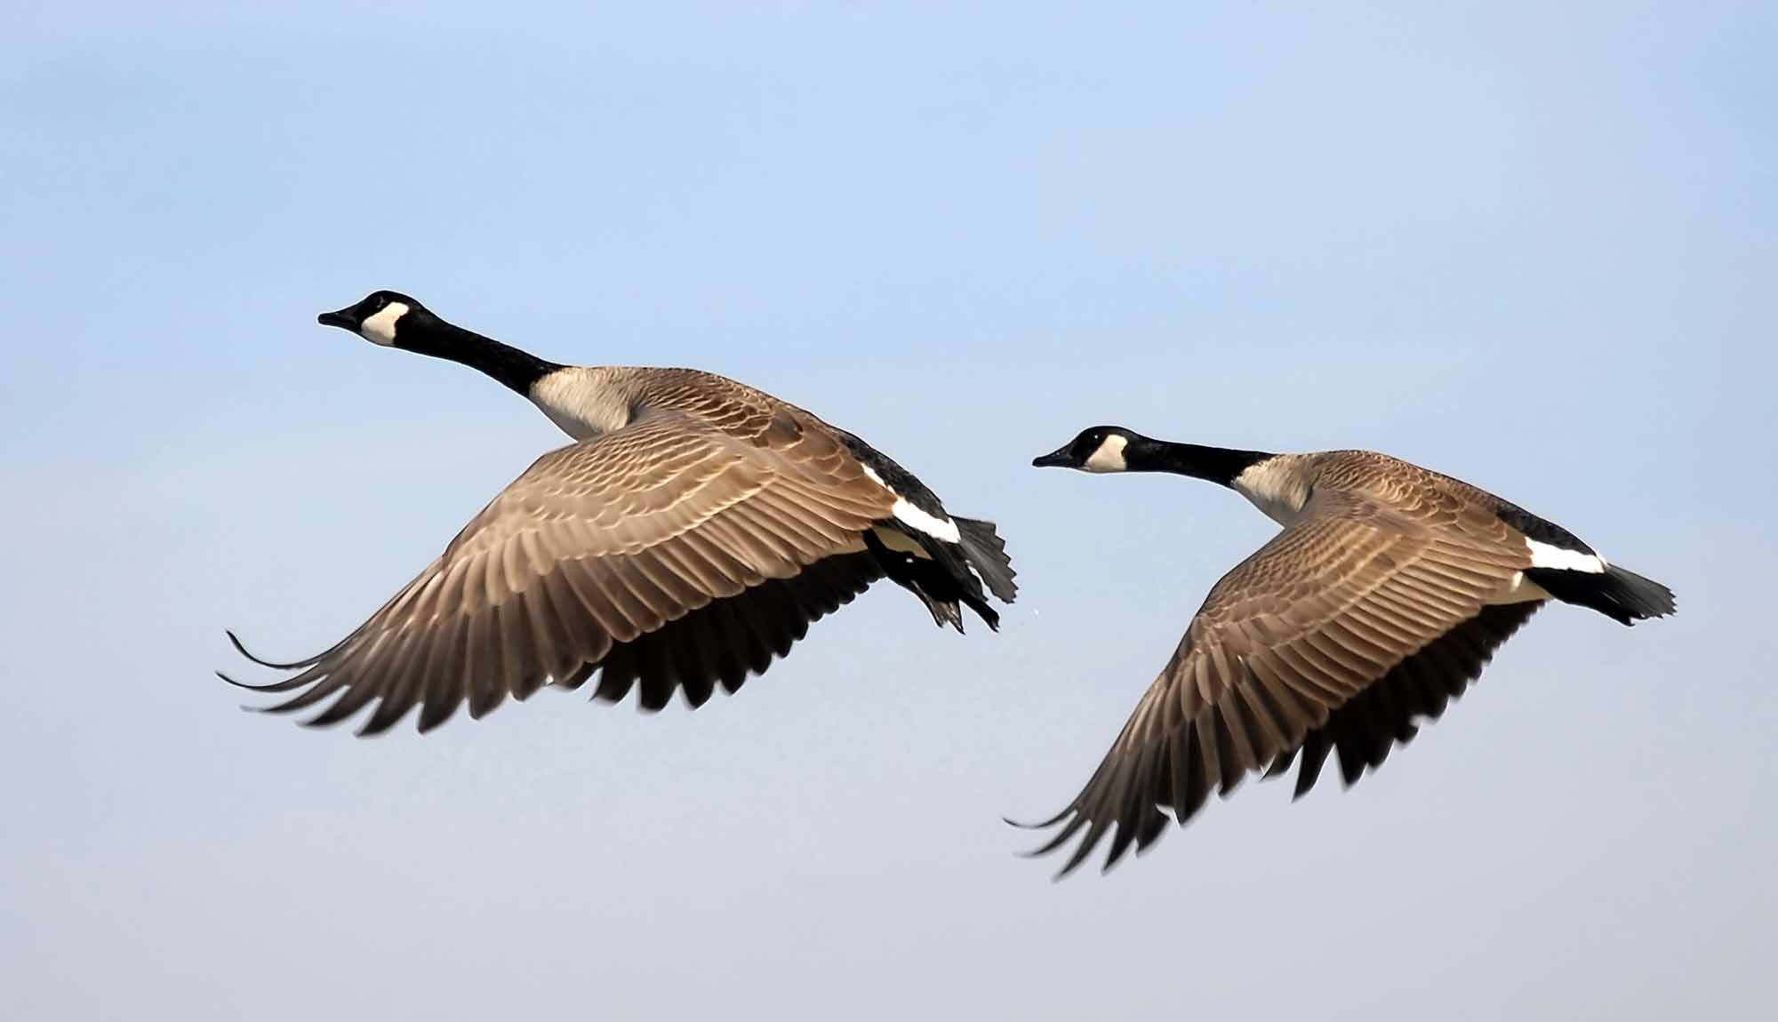

The goose is an animal known to fly down south when the cold Canadian weather comes in early to mid- fall. This is known as behavioural adaptation because they are migrating in a flock to a different place so they can stay warm.

Grizzly bear
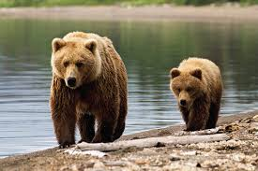

The grizzly bear is an animal who has behavioural adaptions because they hibernate every winter. The bear stays in its cave until early spring, it prepares itself before winter by gathering lots of food like fish, berries and other small animals and plants. The bear makes sure that it is well ready before hibernating because during hibernation they do not use the bathroom, drink or eat.

