Animals and their Adaptations:

Structural (2) -
Platypus - The platypus's bill has sensitive electroreceptors which pick up tiny nerve and electrical impulses generated by crustaceans and other animals
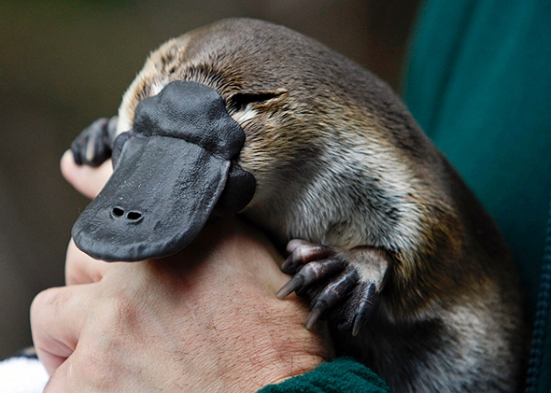

Venus Fly Trap - The leaves of the carnivorous pitcher plant form cups, or pitchers, that fill with water, drowning insects that they then digest.
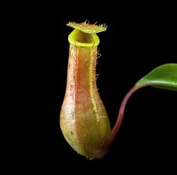

Physiological (2) -
Danish Scurvy Grass - These are white flowers often found by the sea but, due to increasing levels of salt being used on roads to melt ice, they are now being found on the sides of roads.
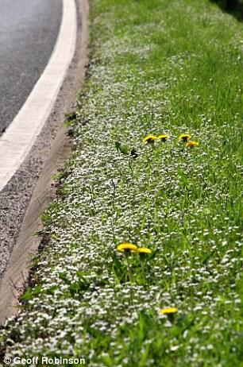

The Giant African Millipede - The giant african millipede is toxic. It makes a poison that it releases through its skin, it keeps it from being a tasty treat for predators.
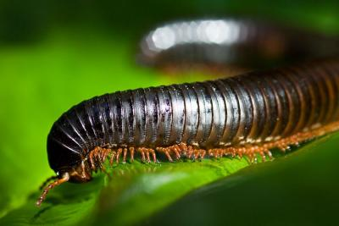

Behavioural adaptations (2)
The Possum - The Possum plays dead for protection from enemies.
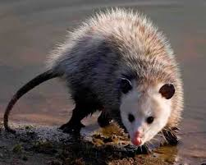

Butterfly - Butterflies migrate for food and warmth.
