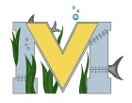
PROJECT #2 PROPOSAL
Name(s): Nick Surette
Team Name:Team RC
Part A: Project Ideas & Objectives 3D Printing to generate parts for an RC car that needs repair. I will be required to design and make a few parts to repair and get the rc car up and running. presently it needs axles. This can be a model to realistic vehicles as many Companies are looking into being able to manufacture 3D parts cheaper and more efficiently.
Part B: Electronic Resources (Make sure hyperlinks are active!)
https://www.youtube.com/watch?v=6eObnwWfqU4
https://www.youtube.com/watch?v=WEncRCdU8GE (my Car)
https://www.youtube.com/watch?v=io7siVPD1MU
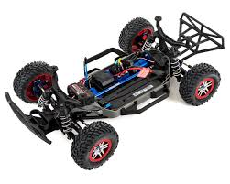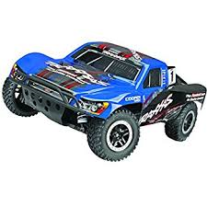
Part C: Materials & Designs
3d printer
Scanner (possibly)
3D Printer Filament
Traxxas slash 4x4
Parts

