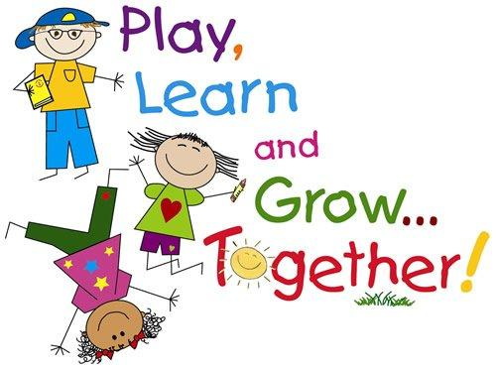**EARLY CHILDHOOD**

**SERVICES 120**

**UNIT I – 6 weeks**

* Professionalism in an ECE Role
* Understanding Two, Three and Four Year Olds
* Observing Children (Learning Stories)
* Preparing the Environment
* Lab Preparation

**UNIT II – 12 weeks**

Organizing and operating a Playschool for preschoolers ranging in age from two-four years and completing 10 chapters from the textbook:

* Lesson 1 – Classroom Limits (Ch. 16)
* Lesson 2 – Guidance Challenges (Ch. 15)
* Lesson 3 – Children’s Health (Ch. 13)
* Lesson 4 – Puppetry Experiences (Ch. 21)
* Lesson 5 – Science Experiences (Ch. 24)
* Lesson 6 – Social Studies Experiences (Ch. 25)
* Lesson 7 – Guiding Children with Special Needs (Ch. 31)
* Lesson 8 – Nutritious Meals (Ch. 12)
* Lesson 9 – Involving Parents & Families (Ch. 32)
* Lesson 10 – A Career For You (Ch. 33)

**BREAKDOWN OF FINAL MARK:**

* Assignments/Quizzes 40%  **TEXTBOOK:**
* Lab Participation 30% Working With Young Children
* Lab Reports 30% Author: Judy Herr
* **NO EXAM**

*Late Policy: All assignments are expected on the day that they are due. Assignments which are passed due will be reduced 10% per day for the first four days. The assignment will be evaluated at 60% for days 5, 6 and 7. After day seven, the mark is zero.*

Welcome to Early Childhood Services 120! This course involves planning, preparing, organizing and operating a playschool with 10-12 children, ages 2-4. Periods 2 & 3 will share responsibilities for operating / teaching three playschools per week (Tuesdays, Wednesdays and Thursdays).

The class will be divided into 4 groups for lab planning, therefore you will be working in a **GROUP SETTING** where you will make decisions, plans, and preparations for each playschool your group will be teaching / operating. Each Group (A, B, C, & D) will be responsible for several playschools throughout the semester – all focusing on interests of the children.

We will have approximately one month before we actually begin the playschool. This time will be used in learning the basics about working with young children, child development, safety, creating environment, etc. It will also be spent organizing activities for the littles ones (Art, Dramatic Play, Music, Science, Games, Storytelling, etc.). Once we start the playschool, you will only have classroom lessons on Mondays and Fridays.

**You will need the following supplies for this course:**

* Duo-tang (to be handed in each week with your lab report)
* Markers or pencil crayons
* Tape
* Scissors

**ATTENDANCE is critical – if this is a problem for you, consider making a course change!**

If you enjoy HANDS ON activity, being creative and having fun with young children then this is the place for you! This is an awesome course where you will learn what being a TEACHER is all about – making plans, meeting deadlines, writing lessons plans, being organized, working with others, dealing with parents, solving problems, and most importantly, enjoying your students.

Best of luck and remember to have fun,

Ms. Grattan ☺