Fashion Technology 110 Course Outline
Semester I (September – January 2018)
Ms. Grattan

Welcome to Fashion Technology 110! The purpose of this program is to learn sewing ability needed to construct beginning sewing projects. Students will learn the basic skills that will allow them to construct and maintain clothing for themselves and their families. Some of these skills for the preparation to sew include: ironing/pressing, taking measurements, textile care, fabric use, pattern use, and cutting and marking techniques. Other skills for clothing construction include: casing, interfacing, machine hemming, seam finishes, gathering, hand-stitching and single dart.
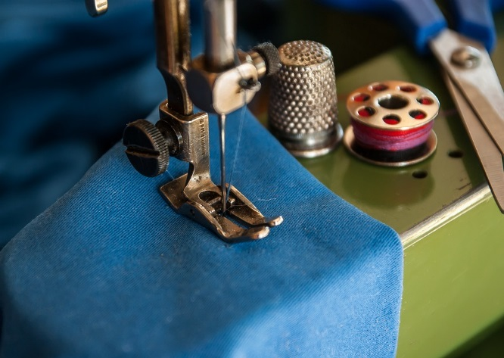
Unit 1 – Preparing to Sew (1-2 weeks)
- Tools & Equipment
- Safety in the lab
- Ironing & Pressing
- Textile care symbols
- Clothes Lines & Colour
Unit 2 – The Pattern, Fabric and Notions (2 weeks)
- Layout of fabric and pattern
- Taking measurements and determining pattern size
- Pattern symbols
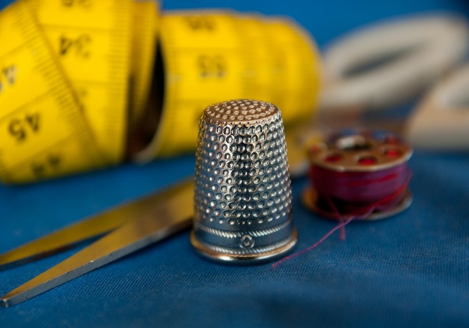
- Understanding the pattern envelope and guide sheet
- Preparing your fabric
- Cutting and marking techniques
Unit 3 – The sewing Machine and Equipment (2 weeks)
- Parts of the sewing machine
- Winding the bobbin and threading the machine
- Tools to help you finish your projects
Unit 4 – Clothing Construction (13 weeks)
- Hand stitching / machine stitching
- Seams and seam finishes ASSESSMENT:
- Mending / alterations Projects / Assignments 60%
Tests, Quizzes, Lessons 30%
TEXTBOOK: Clothing – Fashion, Fabrics & Construction Participation 10%
Late Policy: All assignments are expected on the day that they are due. Assignments which are passed due will be
reduced 10% per day for the first four days. The assignment will be evaluated at 60% for days 5, 6 and 7. After day seven, the mark is zero.

