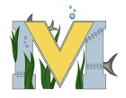
PROJECT #1 PROPOSAL
Name(s): Alex Tozer, Mitchel Hallihan, James MacGregor
Team Name: Sky-High
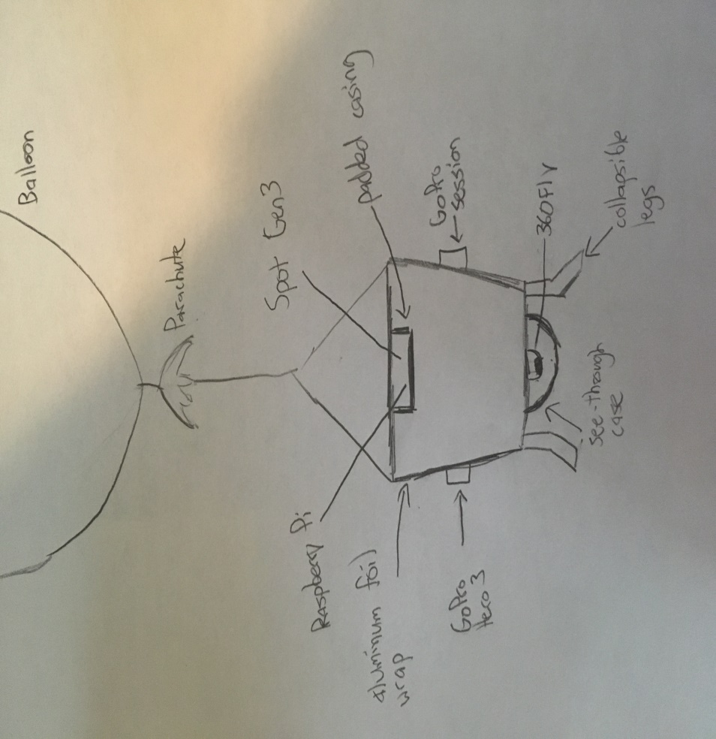
Part A: Project Ideas & Objective
- Continue progress on high altitude balloon
- Familiarize ourselves with equipment necessary (raspberry pi, Spot Gen3, Gopro, 360Fly)
- Ensure safe and successful flight/landing
- Create potential landing device (Testing)
- Possible live-feed video (Livestream for Public Viewing Mid-flight)
- Reinforce box and technology
- Monitor Weather / Create temperature protection for cameras/Technology
- Organize launch party at school
- Monitor Flight prediction website
- Organize date, launch and pick-up
- Create Presentation about results, progress and observations
- Analyze data and prepare for future launch
Part B: Electronic Resources (Make sure hyperlinks are active!)
Flight Predictor- http://predict.habhub.org/
Rothesay Launch- http://rhsspaceflight.wikispaces.com/home
Jacob Lingley's Launch: https://www.youtube.com/watch?v=PK6ics2CnvA
Parachute: https://www.youtube.com/watch?v=q9qDvb6KPJc&feature=youtu.be(link is external)
Helium Calculator: http://tools.highaltitudescience.com/#
GoPro- https://shop.gopro.com/International/Experience
Raspberry Pi- https://www.raspberrypi.org/
Spot Gen3- https://www.findmespot.ca/en/index.php?cid=100
360Fly- https://www.360fly.com/
Balloon Challenge- https://www.balloonchallenge.org/tutorials
High Altitude Balloon Website- http://ourhabproject.com/where-to-start/
Safety- https://space.stackexchange.com/questions/2213/what-are-the-risks-involved-in-amateur-high-altitude-ballooning-and-how-can-we

Part C: Materials & Designs
- Parachute
- Styrofoam Case with GoPro Session Mount/Tether
- GoPro Hero 3 Black
- GoPro Hero Session
- 360 Fly
- Protective Case for 360Fly
- Raspberry Pi 3/Sense Hat/Case
- 20000 mAh Power Pack
- Spot Gen 3 GPS
- 2 Cables
- 2 Carabiners
- Tarp
- Helium
- Balloon

