Hemingway’s First Short Story Found in Key West
By ROBERT K. ELDERSEPT. 29, 2017
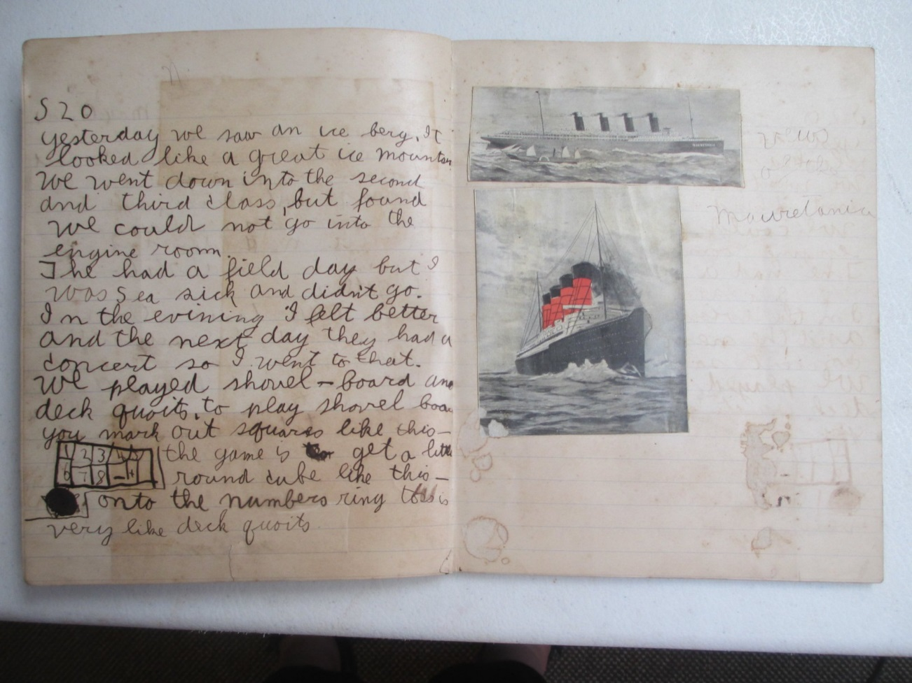
Ten-year-old Ernest Hemingway’s notebook containing his untitled, previously unknown work of fiction. Credit Sandra Spanier
When Hurricane Irma smashed into Key West, Fla., author Shel Silverstein’s historic home was nearly leveled. But it was another home in his neighborhood that had Brewster Chamberlin, a writer and historian, worried.
His friend Sandra Spanier was also nervous. Not only because she feared for Mr. Chamberlin, who weathered the hurricane at home with his wife, but also because they shared a discovery that few people knew about.
In May, she and Mr. Chamberlin found Ernest Hemingway’s first short story — an untitled, previously unknown work that he wrote at the age of 10 — in the archives of the Bruce family, longtime friends of the Hemingways. It was only a few months after she’d first touched the stained brown notebook containing the story, and now this rare artifact could be blown off the island entirely. “I was really terrified,” said Ms. Spanier, the general editor of the Hemingway Letters Project and an English professor at Penn State University.
On Wednesday, Sept. 27, Mr. Chamberlin returned to the archive in Key West’s Old Town neighborhood. He walked past fallen trees and debris lining the yards, sidewalks and streets. “The collection is in fine shape,” Mr. Chamberlin reported. While the property lost several large trees, “there was no damage whatsoever to the building,” he said.
The notebook was there, unharmed, tucked inside a Ziploc freezer bag, with “Sep. 8, 1909,” written in black marker.
But how this notebook traveled from Hemingway’s hometown in Oak Park, Ill., to storage in ammo boxes in Key West is another story. Hemingway was the best chronicler of his own life, or in modern terms: a hoarder. He kept not only photos and letters, but also receipts, ticket stubs, dental X-rays, school assignments, Spanish bullfighting magazines and other ephemera. By the time Hemingway died in 1961, he left scores of material scattered in places such as Key West, Oak Park, Cuba and his home in Ketchum, Idaho.
The author’s fourth wife, Mary Welsh Hemingway, spent years gathering letters, notebooks and Hemingway’s unfinished manuscripts, including the memoir of his Paris years, “A Moveable Feast.” In the winter of 1962, she traveled to Key West to visit Betty and Telly Otto “Toby” Bruce, who retrieved a pile of boxes left in a storeroom behind Sloppy Joe’s Bar, Hemingway’s favorite saloon. Bruce was a longtime confidant who had served as Hemingway’s mechanic, handyman and sometime chauffeur.
Mary took what she deemed important back to New York and gave the rest to the Bruces. With the exception of a few local exhibits and some scholarly collaboration, the archive has remained in family hands, under the control of Bruce’s son, Benjamin “Dink” Bruce.
The collection also includes little-seen Hemingway photos, letters, a lock of the author’s hair and 46 prints, a gift from the famous photographer Walker Evans. Only within the last 15 years has it begun to be properly cataloged, due largely to the efforts of Mr. Chamberlin, who wrote “The Hemingway Log,” a timeline of the author’s life and career.
It’s easy to see why Mary might have overlooked the water-specked notebook. Only a piece of the cover survives, on which the young Hemingway drew a map of the north-central United States. The untitled story takes up about 14 pages of the notebook, which also includes bits of poetry and notes on grammar, including rules for capitalization and punctuation.
Hemingway’s travelogue through Ireland and Scotland was written as letters to his parents and what seem to be diary entries, so it didn’t seem significant. It was only when Ms. Spanier visited Mr. Chamberlin in May that they realized Hemingway never made this trip, as a child or as an adult. It was then that the full weight of the discovery hit them. “Oh my God, I thought, this is quite something. This is Hemingway’s first attempt at fiction,” Mr. Chamberlin recalled thinking.
In one section of the notebook, young Hemingway tells the story of a dead man who returns once a year to rebuild Ross Castle in Ireland, and host a nighttime feast. “When daylight comes the castle falls in ruins and O’Donahue returns to his grave,” wrote Hemingway in a spidery scrawl.
Although Hemingway’s penmanship wouldn’t improve much, his writing would. The story foreshadows the writer to be, not only in terms of Hemingway’s economy of language and use of landscape, but also in his mixing of reportage with fiction. This is a technique Hemingway would employ throughout his career to inject realism into his stories, to ground them with gravity of facts and experience. “I thought this was really amazing; a real landmark piece of writing,” Ms. Spanier said. “It’s the first time we see Hemingway writing a sustained, imaginative narrative.”
The young Hemingway goes on to describe a tour of Blarney Castle and the poverty of Ireland. He writes about a visit to a stone house with a thatched roof that “is very dark inside” and about a pig that “runs under the table” and “the people call him ‘The little fellow that pays the rent.’ ”
There are no grade marks on the piece, so it’s unknown whether this was a draft of an English assignment, or if Hemingway was writing for his own amusement. He may have intended it for St. Nicholas Magazine, Ms. Spanier said. The children’s magazine held a monthly literary contest that his older sister Marcelline had entered.
“Maybe he was inspired to write his fictional — and rather learned and literary — narrative by the prospect of being a published author at the age of 10,” Ms. Spanier suggested.
As for Dink Bruce, he couldn’t be more surprised by the whole thing, although time and the recent hurricane have made him rethink the future of the archive.
“A tornado can take them out, but they are as safe as they can be right now,” said Mr. Bruce, who splits his time between Key West and Livingston, Mont.
He’s considering selling the archive, so it can find a new home inside or outside of Florida.
“It deserves to be in some place where it can be studied,” he said.

