Don't let anyone get away with ageism, author says
U.S. writer Ashton Applewhite is making it her mission to fight ageism, and she hopes she's lit a fire in New Brunswick for a new social movement.

'The underlying message is to grow old is to lose value as a human being'
Elizabeth Fraser · CBC News · Posted: Apr 13, 2018 2:32 PM AT | Last Updated: April 13

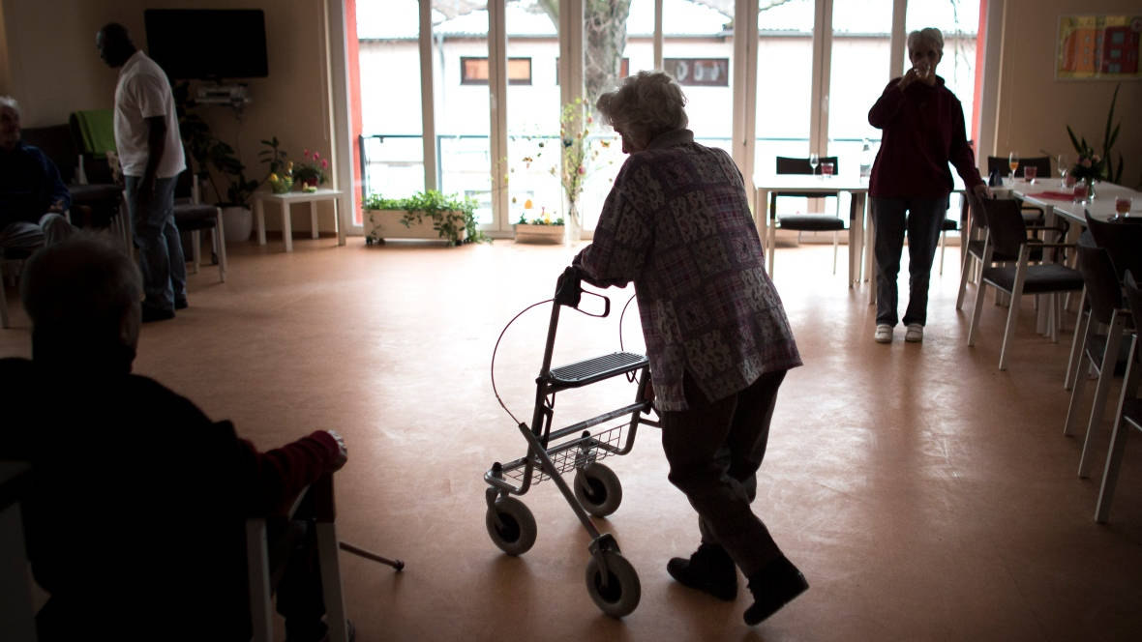
New York writer Ashton Applewhite says ageism 'is all over the place' in a society obsessed with youth, but the prejudice can also hurt young people. (Carsten Koall/Getty Images)

A U.S. writer is making it her mission to fight ageism, and she hopes she's lit a fire in New Brunswick for a new social movement. "Ageism is discrimination and stereotyping on the basis of age, which is really any judgment about a person on the basis of how old we think they are," said Ashton Applewhite.
The author of This Chair Rocks: A Manifesto Against Ageism was the keynote speaker at the New Brunswick Innovation Foundation gala Thursday in Fredericton.Whether in the workplace or out on the street, ageism "is all over the place," she said. People aren't truly aware of this form of prejudice or the harm it can do, the Brooklyn activist said.
Give people a chance and don't write them off on the basis of age.- Ashton Applewhite
Although she hasn't experienced much ageism in her own life, she said, a society "obsessed with youth" can be damaging to older people."We say denigrating things on the basis of age all the time that you would never say on the basis of race or sex," Applewhite said.
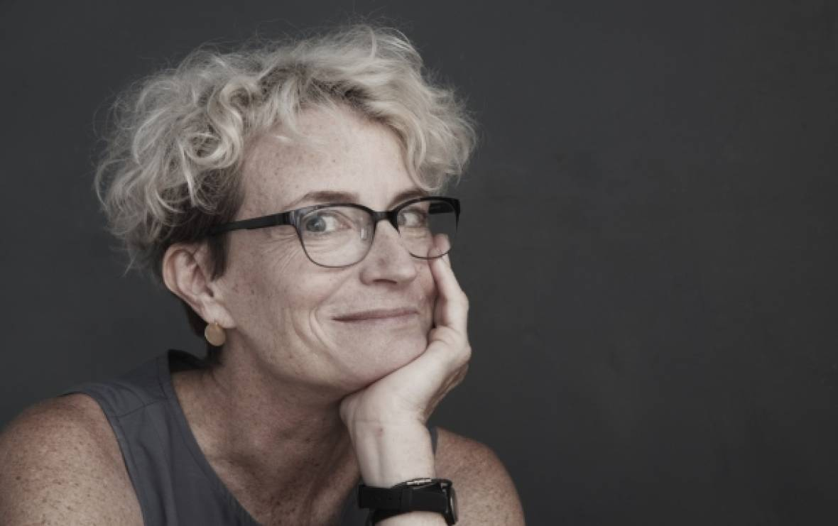
Applewhite, the author of This Chair Rocks: A Manifesto Against Ageism, was the keynote speaker at the New Brunswick Innovation Foundation gala in Fredericton. (New Brunswick Innovation Foundation website)

"The underlying message is to grow old is to lose value as a human being, which is a pretty terrible thing to grow up believing." This can damage a human being's ego and future, she said. Applewhite pointed to descriptions of seniors as incompetent, wrinkles as ugly, and aging as sad. "If we don't stop and challenge those ideas, they become part of our identity."

How to eliminate it
Applewhite compared the fight against ageism with the women's movement of the 1960s and 1970s, when women began comparing notes. Until then, a woman who wasn't heard or hired considered these her own personal problems, when, in fact, they were collective problems that required collective action, she said.
"It shouldn't be OK to discriminate on the basis of age any more than on the basis of sexual orientation or the colour of your skin, or anything else about ourselves that we cannot change," she said. If people are turned away from jobs because of age, then it's a political problem that also requires collective action.
And seniors aren't the only people who face age discrimination, Applewhite said. The young run into it as well. "It could also be that someone is too young to possibly know their way around a certain task," she said.
Whether a person is too young or too old, people should call out ageism when they see it."If we don't call out discrimination, nothing changes," she said. "Give people a chance and don't write them off on the basis of age."

