Planet project
Due: March 14, 2018

- Each group will be assigned a planet by the teacher.
- Each group will research and present their finding to the class.
- Each group must find 6 unique facts about their planet
(not from the book) and all of the information required to fill out the worksheet on all PLANETS.
- This information is to be presented to the class, therefore please be creative (a model of the planet can be created).
- So you are teaching the class about your planet and you must provide them with notes. You will present your project on the SmartBoard.

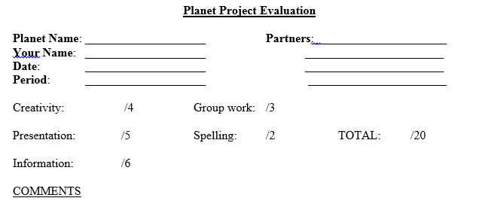

Planet project
Due: March 14, 2018

- Each group will be assigned a planet by the teacher.
- Each group will research and present their finding to the class.
- Each group must find 6 unique facts about their planet
(not from the book) and all of the information required to fill out the worksheet on all PLANETS.
- This information is to be presented to the class, therefore please be creative (a model of the planet can be created).
- So you are teaching the class about your planet and you must provide them with notes. You will present your project on the SmartBoard.

