Autotrophs

Self-feeders, organisms that producer their own food

Heterotrophs

Organisms that must take in food that is made by another organism

Thermodynamics

The study of energy relationships

1st Law of Thermodynamics

Energy cannot be created or destroyed but can change form

2nd Law of Thermodynamics

Conversions of energy produce heat

Entropy

Energy unavailable to do work

Exergonic Reactions

Reactions in which the initial reactants have more energy than the final product

Endergonic Reactions

Reactions in which the initial reactants have less energy than the final product

Enzymes

Proteins that regulate reactions

Oxidation

Loss of electrons

Reduction

Gaining of electrons

Photosynthesis

Process by which organisms use sunlight to produce their own food
6H₂O+6CO₂--Sunlight--C₆H₁₂O₆+6O₂
Water Carbon Dioxide Sun Glucose Oxygen

_{ATP}

Energy used by cells to carry out functions

_{Chlorophyll}

Pigment that makes plants green

_{Light Dependent Reaction}

Light energy is converted into chemical energy and stored as ATP and NADPH₂

Grana

Stacks of thylakoid disks which is where photosynthesis begins

Carbon Fixation Phase
Calvin Cycle

Energy from ATP and NADPH₂ is used to combine carbon dioxide and water into glucose

Glucose

C₆H₁₂O₆

Cellular Respiration

The chemical process that generates most of the energy in the cell
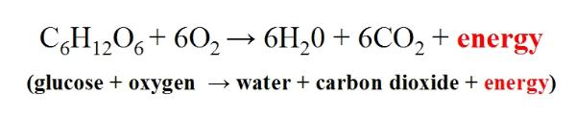

Glycolysis

The splitting of glucose which produces a net gain of 2 ATP molecules

Kreb’s Cycle

Produces 1 molecule of ATP per molecule of pyruvate

Electron Transport Chain

Produces 32 molecules of ATP

Aerobic Respiration

Takes place in the presence of oxygen and produces 36 molecules of ATP

Anaerobic Respiration

Takes place in the absence of oxygen and produces 2 ATP

