Important Information:

Chapter 10
Conversions: R.P. → moles Divide by Avogadro’s number (6.02 x 10²³)
Moles → R.P. Multiply by Avogadro’s number (6.02 x 10²³)

Mass → moles Divide by Molar mass
Moles → mass Multiply by molar mass

Volume → moles Divide by 22.4L/mol (at STP)
Moles → volume Multiply by 22.4L/mol (at STP)

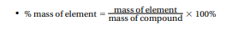

Diatomic Molecules H₂, N₂, O₂, F₂, Cl₂, Br₂, I₂
(other) P₄, S₈

Chapter 12
Chapter 16
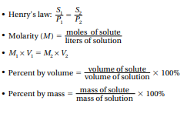

All other relevant information can be found on the periodic table at the end of your exam.

