Reading fiction can be a practical and cost-effective approach to countering violent extremism
Feb. 26, 2018, 12:00 am
By NICCOLA MILNES
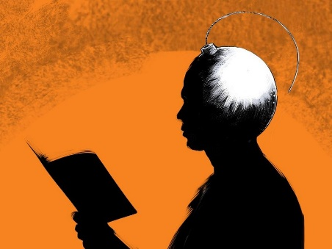
Over the past several years, the world has seen an increase in extremism. Not only has the 2017 Global Peace Index concluded there has been a rise in terrorism from 2007-2017, but data shows that there has also been a rise in far-right political parties and alt-right groups across the globe. Unfortunately, but unsurprisingly, this has led the Global Peace Index to conclude that the world has become significantly less peaceful.
In East Africa, Kenya has borne the brunt of the region’s terrorist attacks, and this has led the country to place a premium on programmes that counter violent extremism. Extremism and radicalisation are now recognised as home-grown problems, and may require a pivot towards home-grown solutions.
One interesting thing about extremism, regardless of where it lies on the political or religious spectrum, is that individuals subscribing to its ideologies have been found to lack empathy. At a time when fields in academia and policy are concluding that it is inherently difficult to isolate individual traits that necessarily lead to extremism, radicalisation, and terrorism, this is an important fact.
Data show however that it is not only extremists who have been found to lack empathy. A wide scale longitudinal survey found that college students are about 40 per cent lower in empathy than their counterparts 30 years ago. Empathy is the ability to understand the emotions of others by feeling them in oneself. Humans are not born with empathy, but develop it throughout childhood. When children fail to develop empathy, studies show they are prone to anti-social and self-destructive behaviour.
Children lacking empathy have been shown to fail in school more often, and experience serious difficulty in maintaining productive social roles. Given how critical empathy is to social relations, it is interesting that it has not been given more attention by policymakers focused on countering violent extremism, and peacebuilding. Especially because there may be a scalable, low-cost option to increase empathy and possibly reduce extremism.
Over the last 20 years, numerous empirical data have been produced showing that reading books enhances empathy. In particular, reading fiction enhances empathy, not only immediately after exposure to a book, but also weeks and months after. These findings have been re-produced in both children and adults across the globe. Data has shown that when children read fiction, their attitudes towards stigmatised groups improved significantly. Similarly, after reading fiction children have been shown to have improved attitudes and intentions, and decreased stereotyping.
An important detail in this effect, is that the results are not reproduced when an individual reads non-fiction. Whether it was a biography or a textbook or a newspaper article, empathy was unchanged, and in some instances, it decreased. At a time when schools are closing their libraries across the globe, and when children in Kenya have little time to read anything other than their textbooks and revision books, this is cause for concern.
In their 2017 paper ‘Can Education Counter Violent Religious Extremism?’, Ratna Ghosh and her colleagues note that the primary role of schools is to promote development of peaceful and inclusive societies. To do this, they argue, education must address both those who are at risk, and those students whose actions may, deliberately or inadvertently, marginalise the other and push them towards the path of extremism.
Given that extremism is associated with lower levels of empathy, and studies show a significant decline in empathy in the general population, then interventions should be considered that help increase the empathy of individuals, if a more peaceful society is the goal. The research shows that it should be the students susceptible to extremism and their peers who are targeted for approaches intended to bring peace and tolerance to learning environments.
Getting schools to create reading programmes that expose children to fiction could be a cost-effective approach to reduce violence and extremism in all of its forms. Many approaches have been tried over the last 10 years, but the research shows that there is potential for a simple home-grown solution to Kenya’s home-grown problem: Get kids to read more fiction.

